Milestone 3 – Completed Functionalities with Screenshots
FOR

LICENSE & BI DASHBOARD WEB APPLICATION
SUBMITTED TO
IVTECH COMPUTER SYSTEMS LLC

Version: 1.0

13th JUNE 2025

Prepared By:
SPEC INDIA
Revision History

Date | Version | Author | Created / Updated / Reviewed / Verified / Approved By
13-06-2025 | 1.0 | Parth Jotangiya | - Initial Draft
13-06-2025 | 1.0 | Yaman Kavishwar | - Reviewed and approved

Table of Contents
Contents
1. Introduction 4
1.1. Items in the Scope 4
1.2. Items outside the Project Scope 5
2. Detailed Screenshots for Each Functionality 6
2.1 License Web Application (Partial) 6
2.2 Camera API Understanding and Integration 6
2.3 BI Dashboard Web Application (Partial) 8
2.4 Data Ingestion (Partial) 38

Introduction

- This document serves as a comprehensive summary of all the functionalities that were planned, developed, and completed as part of Milestone 3 for the License & BI Dashboard Web Application project. It includes detailed information about each feature, covering its objective, scope, and expected behavior.
- Each functionality is thoroughly described and supported with annotated screenshots to visually demonstrate successful implementation. These visual validations help in ensuring that the delivered features align with the requirements and offer clarity for future reference, testing, or client verification.

Items in the Scope

Sr. No | Functionality Title | Description | Status
1 | License Web Application (Partial) | - Allows users to log in using their credentials.  - Super users can create and manage sub-users.  - Role-based access: create and manage roles and their permissions.  - Manage customer and distributor details.  - Generate and email licenses to distributors. | Completed
2 | Camera API Understanding and Integration | - Reviewed SUN API and Wise API documentation.  - Gained complete understanding of available features and functionalities as per the scope.  - Focus on retrieving camera details and associated event data | Completed
3 | BI Dashboard Web Application (Partial) | - User authentication with credential-based login.  - Super users can manage sub-users.  - Role and permission management.  - Ability to manage camera devices and AI boxes.  - Floor plan and zone management.  - Camera-to-zone configuration.  - Multi-site management. | Completed
4 | Data Ingestion (Partial) | - Scheduled using cron jobs at specific time intervals.  - Ability to replicate data from camera devices. | Completed

Items outside the Project Scope

- Creation of APIs which will be directly interacted with AI camera managed by Hanwha.
- SPEC INDIA will only utilize camera APIs managed by Hanwha and will replicate/ingest the necessary information in the database (if required) & display that required information on the web application.
- Multilingual support for web application. Application will be only in English language.
- Responsiveness to Tablet & Mobile. Application will be supported to desktop computer screen only.
- The development of Mobile Application for Android and iOS native integration will be out of scope.
- QA Testing is out of scope because client team will do it from their end.
- Failover plan for the database in case of any future failures.

Detailed Screenshots for Each Functionality

License Web Application (Partial)

The License Web Application is a centralized platform designed to efficiently manage user access, licensing, and customer-distributor relationships for software license products. It allows authenticated users to securely log in, while super users can create and manage sub-users with specific roles and permissions through a flexible role-based access control system. This ensures that each user only has access to the features and data relevant to their responsibilities.

In addition, the application streamlines customer and distributor management by allowing users to store and maintain essential contact and business details. One of its key features is the ability to generate and email software licenses directly to distributors, enhancing operational efficiency and reducing manual errors. This functionality makes the system ideal for organizations seeking a secure, scalable, and user-friendly solution for license management.

Here is the link of created Figma Design for License Web Application: Click Here

IMPORTANT NOTE:
Initially, it was planned to deliver the License Web Application partially under Milestone 3. However, due to changes in the execution plan and a comprehensive flow of requirement gathering, all associated features and functionalities were finalized at the very first stage. As a result, SPEC INDIA successfully developed and demonstrated the complete License Web Application to Bala and his team on Thursday, 24th April 2025 at 5:16 PM IST. The demonstration was well-received, and Bala shared his appreciation via email on Friday, 25th April 2025 at 10:27 AM IST:

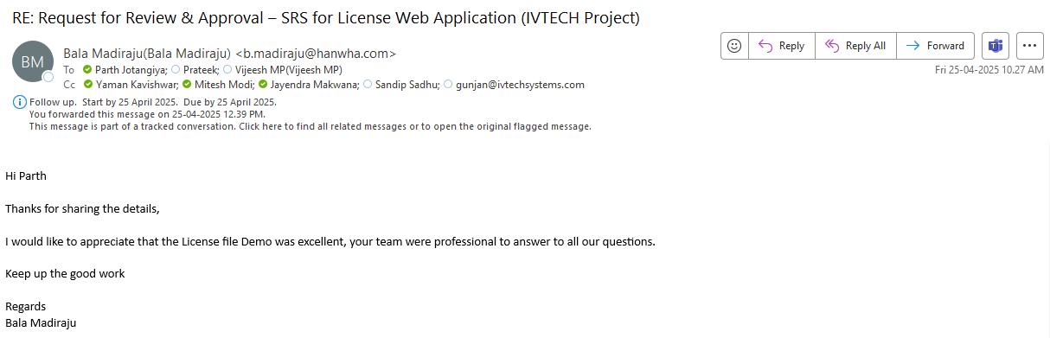

Camera API Understanding and Integration

The SPEC INDIA team has thoroughly reviewed all the documents shared by Bala and his team related to the SUNAPI and Wise APIs. During the review, the team encountered several uncertainties regarding the exact API endpoints required for specific features and functionalities. To address these concerns, we reached out to Bala, who subsequently scheduled meetings with their HQ Team to obtain the necessary insights on API integration and endpoint details.
Following multiple discussions with the HQ Team, particularly with Sujith, we have successfully prepared a detailed XLS file outlining and finalizing the API endpoints associated with each feature and functionality that involves Camera API calls.

We continue to follow the same practices whenever we require any further assistance or clarifications.

Screenshots:

- Please find below a few screenshots from our email conversations highlighting the discussions around API understanding and integration details:
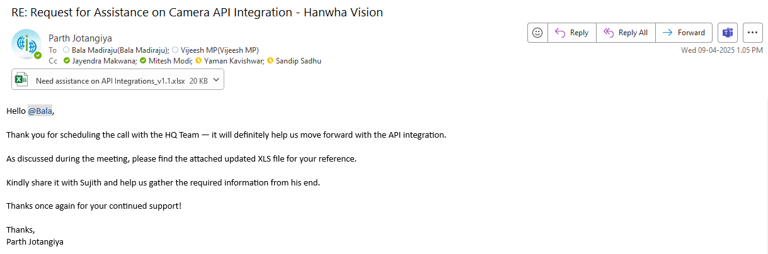
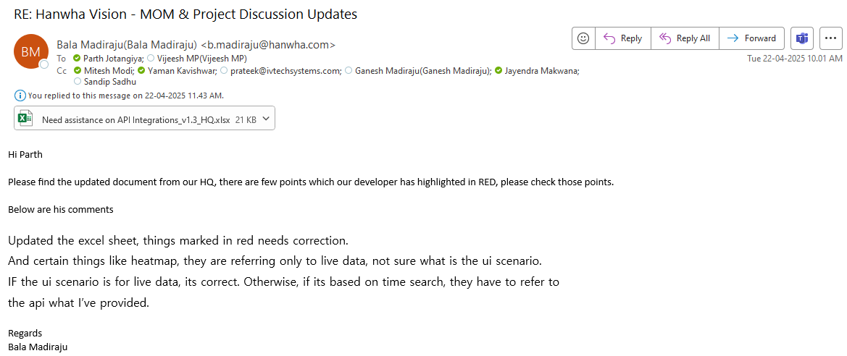

BI Dashboard Web Application (Partial)

The BI Dashboard Web Application is a platform designed with key foundational modules to support user access control and device management. It includes a secure, credential-based user authentication system, and a comprehensive role and permission management structure that allows super users to create and manage sub-users with varying levels of access based on assigned roles.

Additionally, core functionalities have been developed for camera and AI box management, enabling authorized users to add, update, or remove devices. The system features floor plan and zone management, allowing users to define layouts and associate specific areas with camera zones. A camera-to-zone configuration module has also been implemented to map devices to their respective zones. Furthermore, the application supports multi-site management for deployments across multiple locations. Users can track and acknowledge generated events, configure system settings, and customize their dashboard by adding or removing widgets as needed.

Here is the link of created Figma Design for BI Dashboard Web Application:
- Light Theme: Click Here
- Dark Theme: Click Here

IMPORTANT NOTE:

Milestone 3 includes the delivery of the following features:

- User authentication with credential-based login.
- Super users will have the ability to manage sub-users.
- Role-based access control with permission management.
- Functionality to manage camera devices and AI boxes.
- Floor plan and zone configuration capabilities.
- Mapping of cameras to designated zones.
- Support for managing multiple sites.

1) User authentication with credential-based login

This involves implementing a secure system for users to log in using unique credentials (e.g., username/email and password).

Screenshots:

- The system will perform field validation when a user attempts to log in without entering unique credential details:
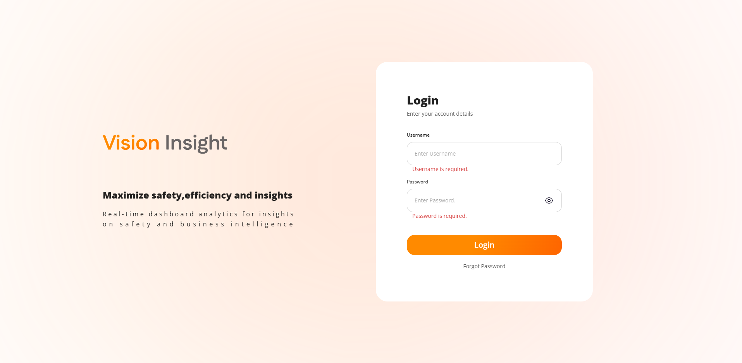
- The system will authenticate valid credentials when the user attempts to log in using their unique credentials. If the credentials are not valid, the system will display an appropriate error message to the user:
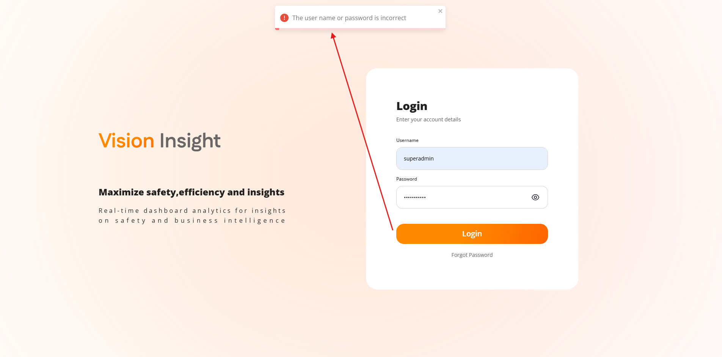
- The system will display the following popup message when a user attempts to use the "Forgot Password" option, as the system does not allow users to reset their own passwords:
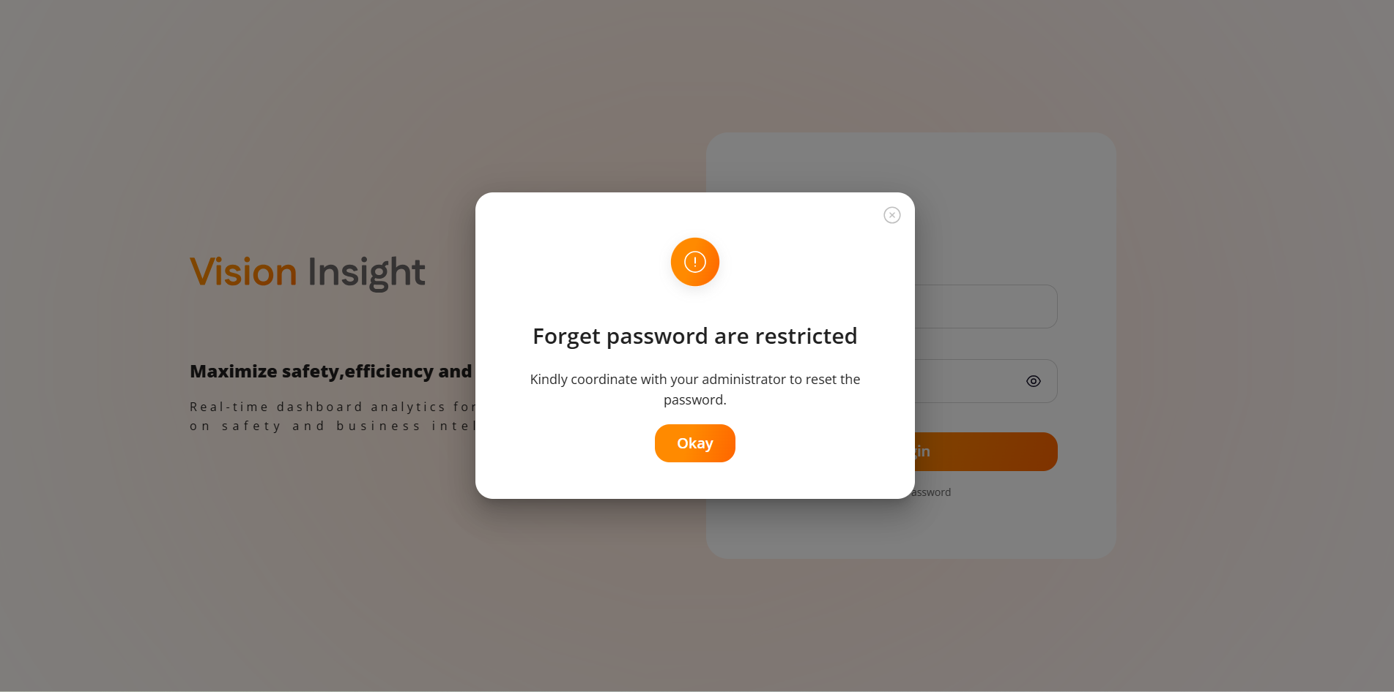
- The system will allow the user to toggle the visibility of the entered password by clicking on the eye icon, as highlighted below:
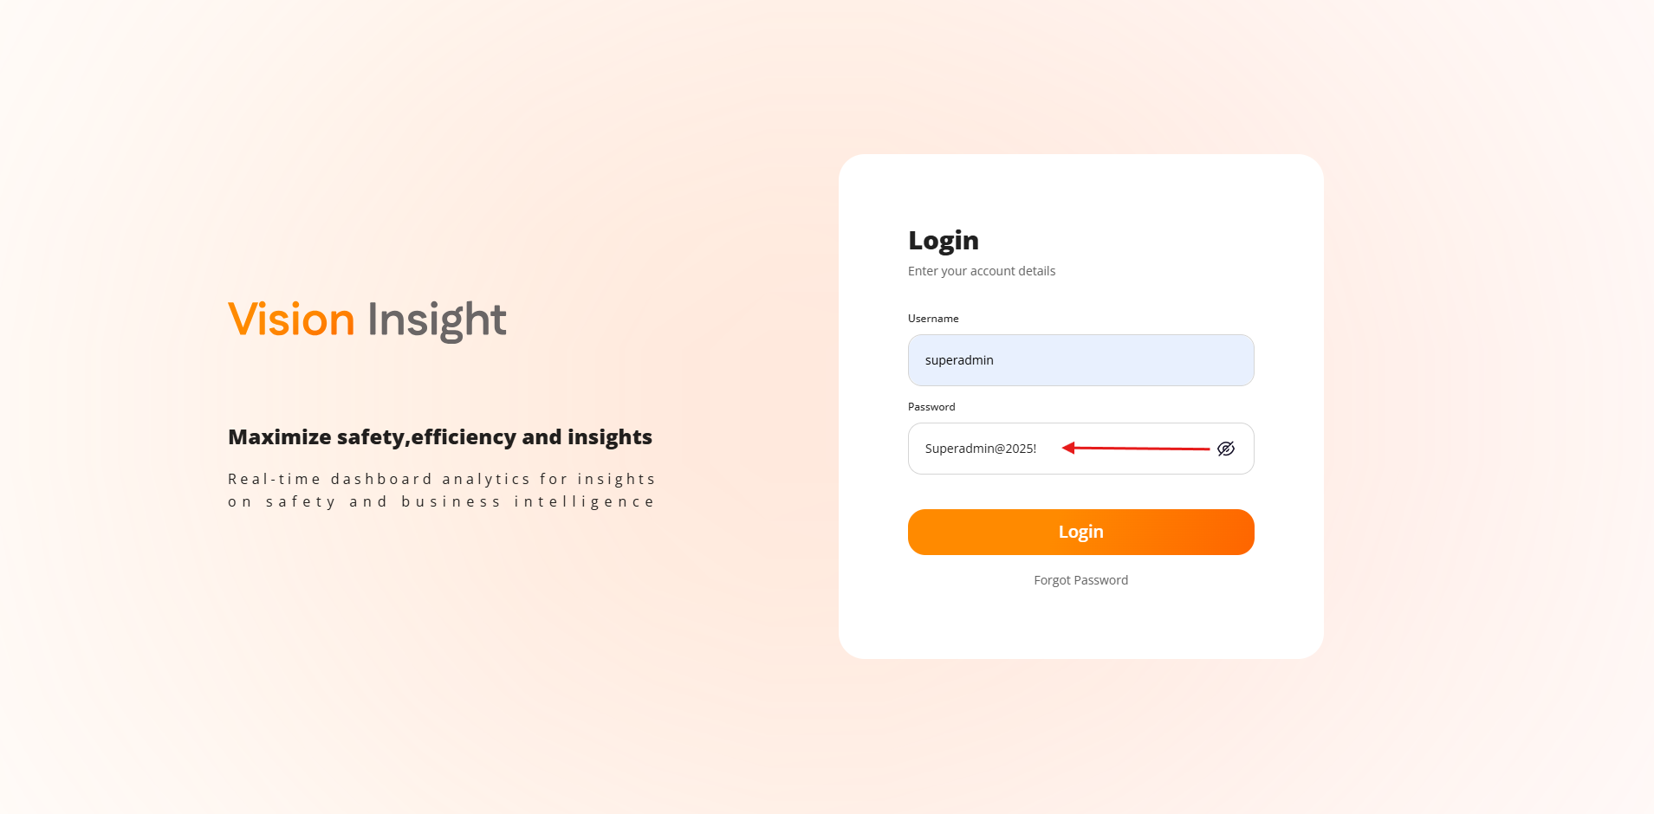

- After a successful login, users will be redirected to the Welcome page:
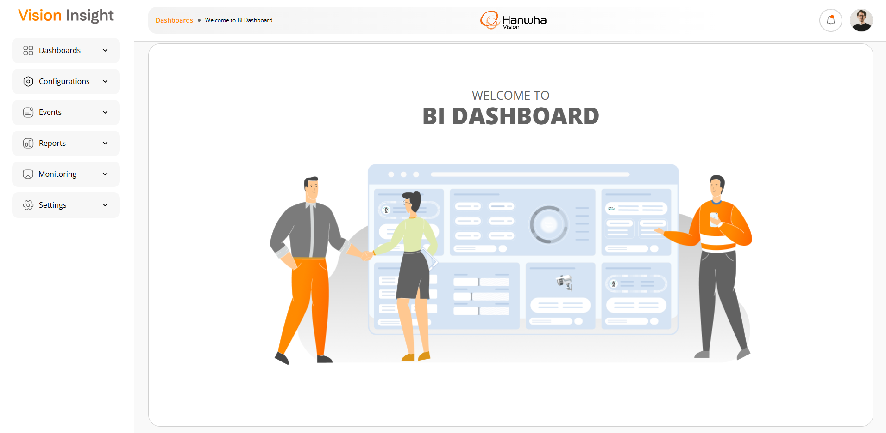

2) Super users will have the ability to manage sub-users

Super users will have the capability to create, modify, and delete sub-user accounts, providing hierarchical control over user access.

Screenshots:

- The screen below displays the list of all created users, along with options to Search, Add, Edit, and Delete users:
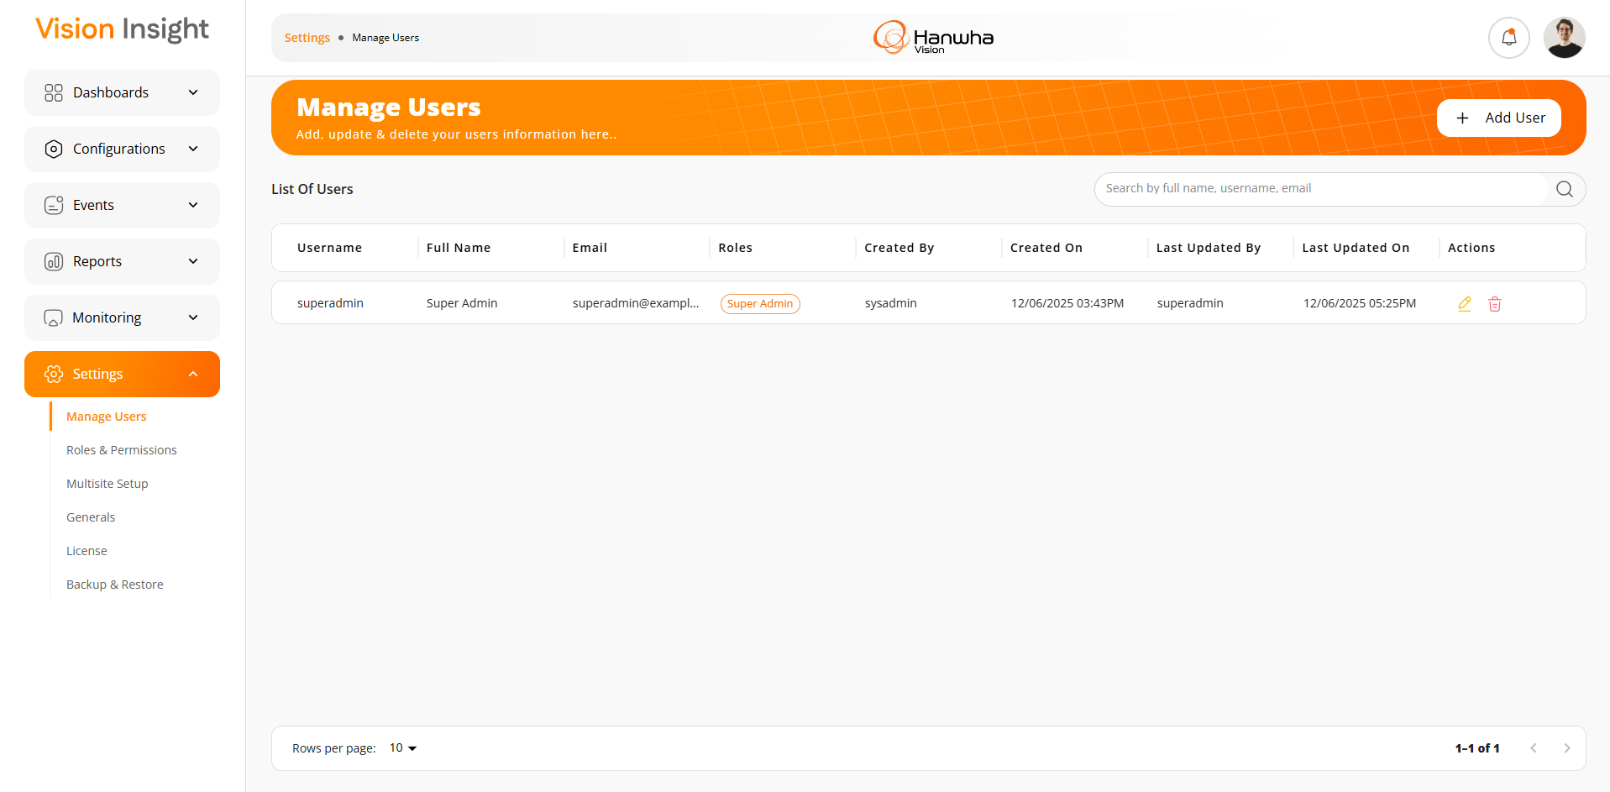

- The screen below represents the form for creating a new, allowing users to enter relevant details and submit the information for user creation:
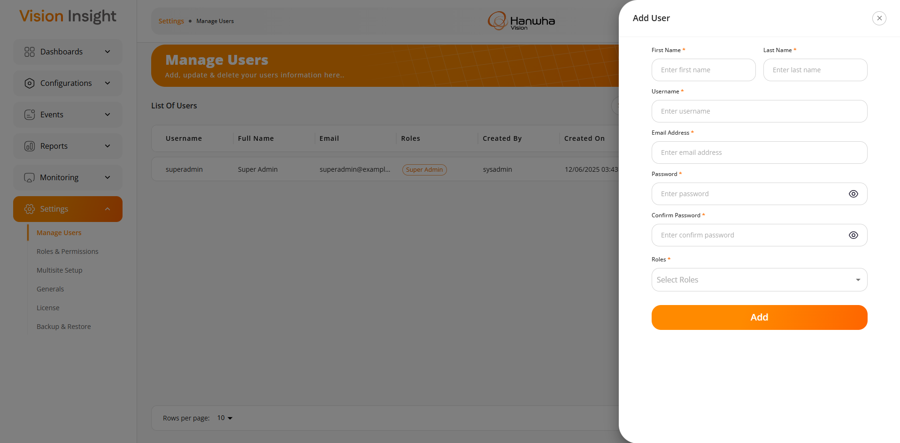
- The system will perform all necessary validations when adding a new user to ensure the entered information is valid and accurate:
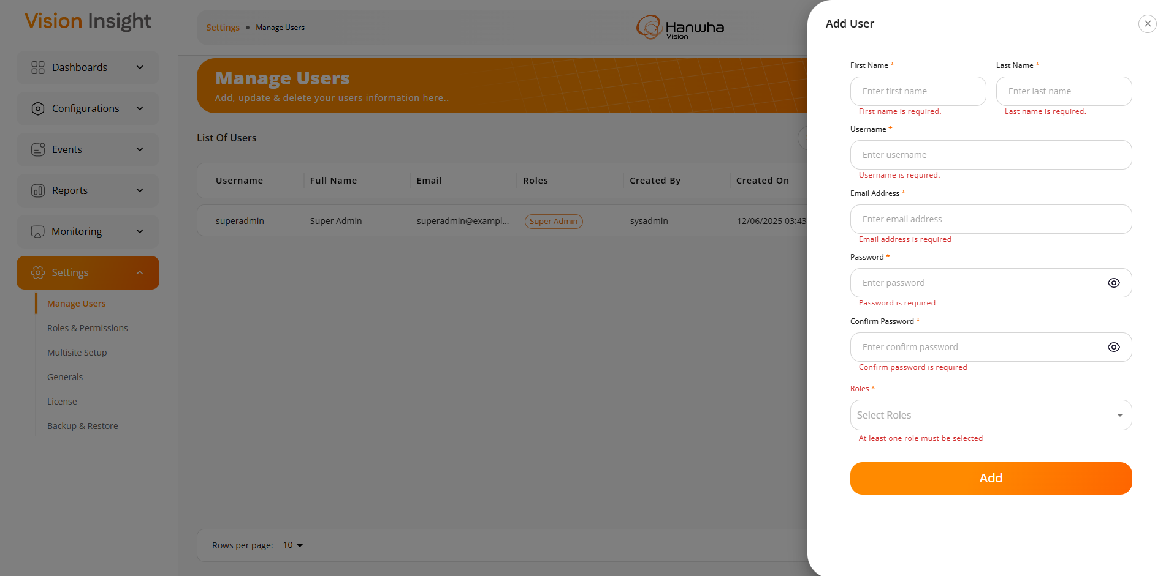
- The system will perform validation on both the Password and Confirm Password fields. If the values do not match, the system will display an appropriate error message to the user:

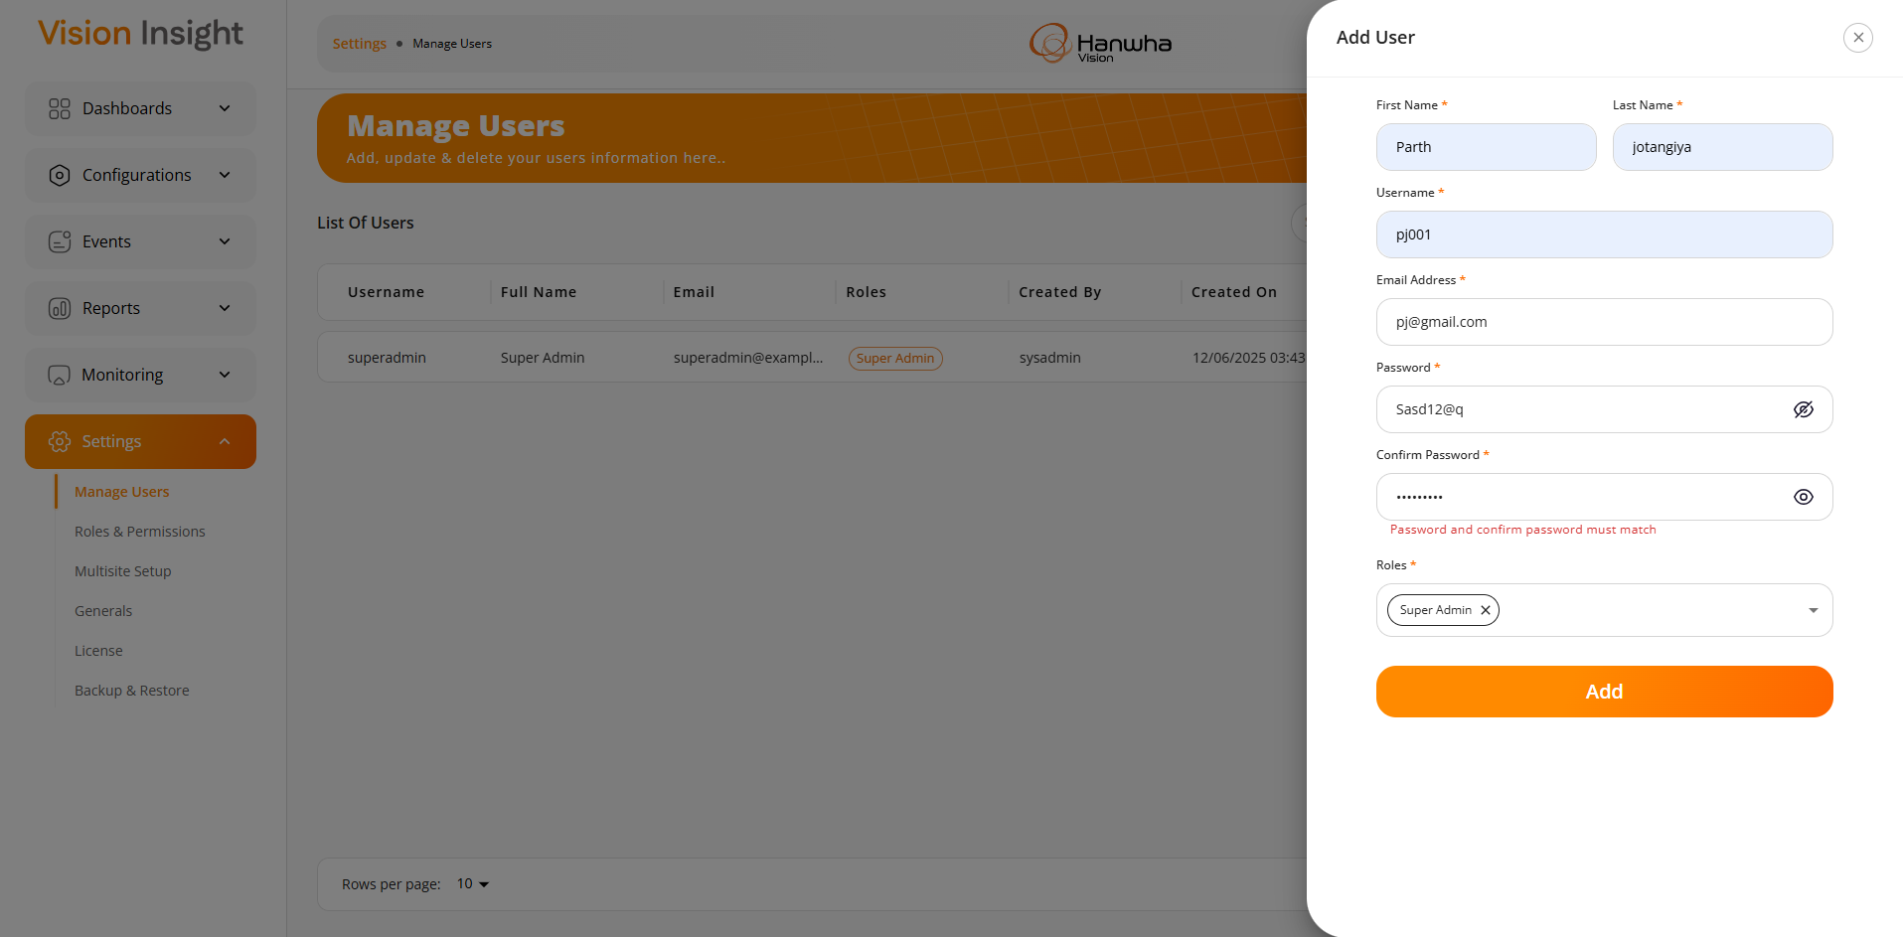
- The system will display an appropriate validation message when a user attempts to enter a duplicate email address or username that already exists in the application. This ensures that there are no duplicate entries with the same email address or username, as these are used as login credentials:
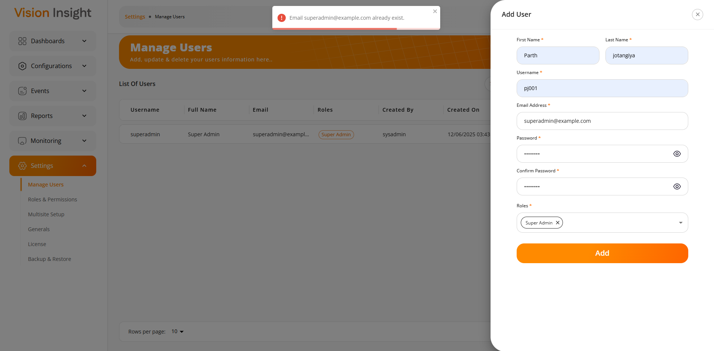
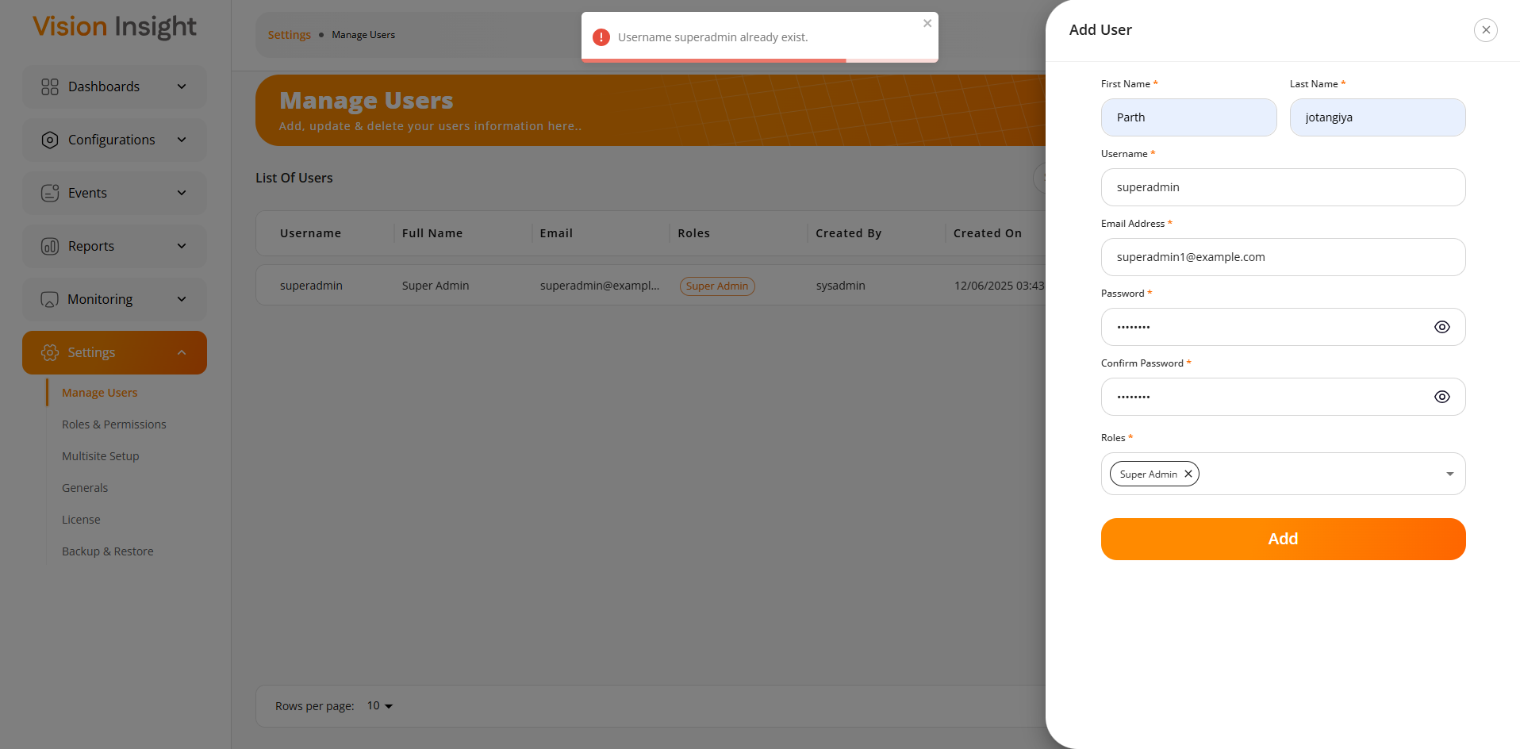
- The system will display the following message when a user attempts to add a new user, but the license limit for the number of allowed users has been exceeded:
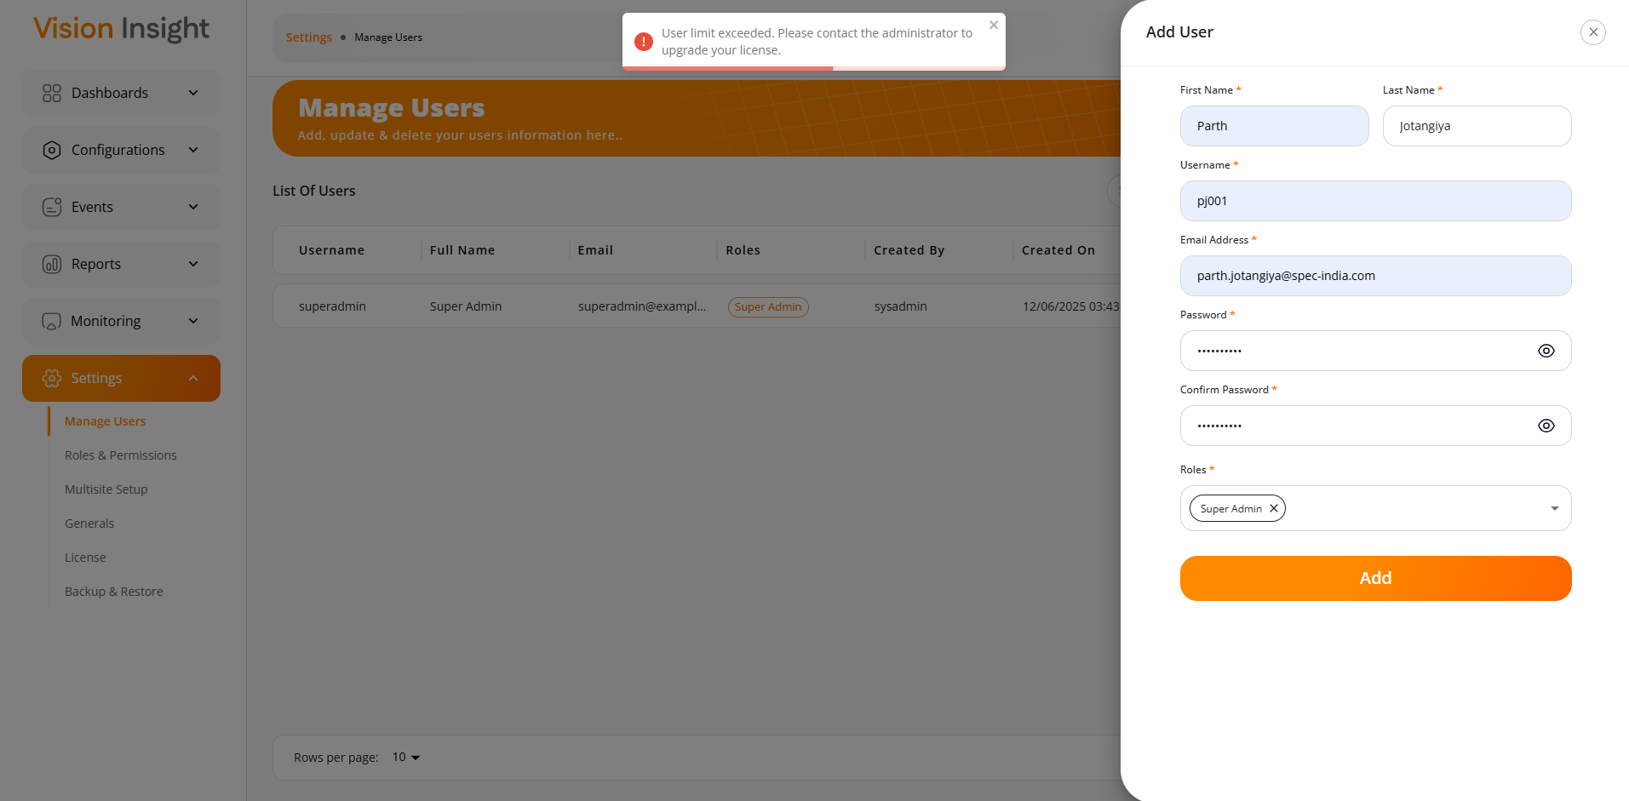
- Authorized users can edit any user’s information using the form shown below. Upon successful update, the system will display the following success message:

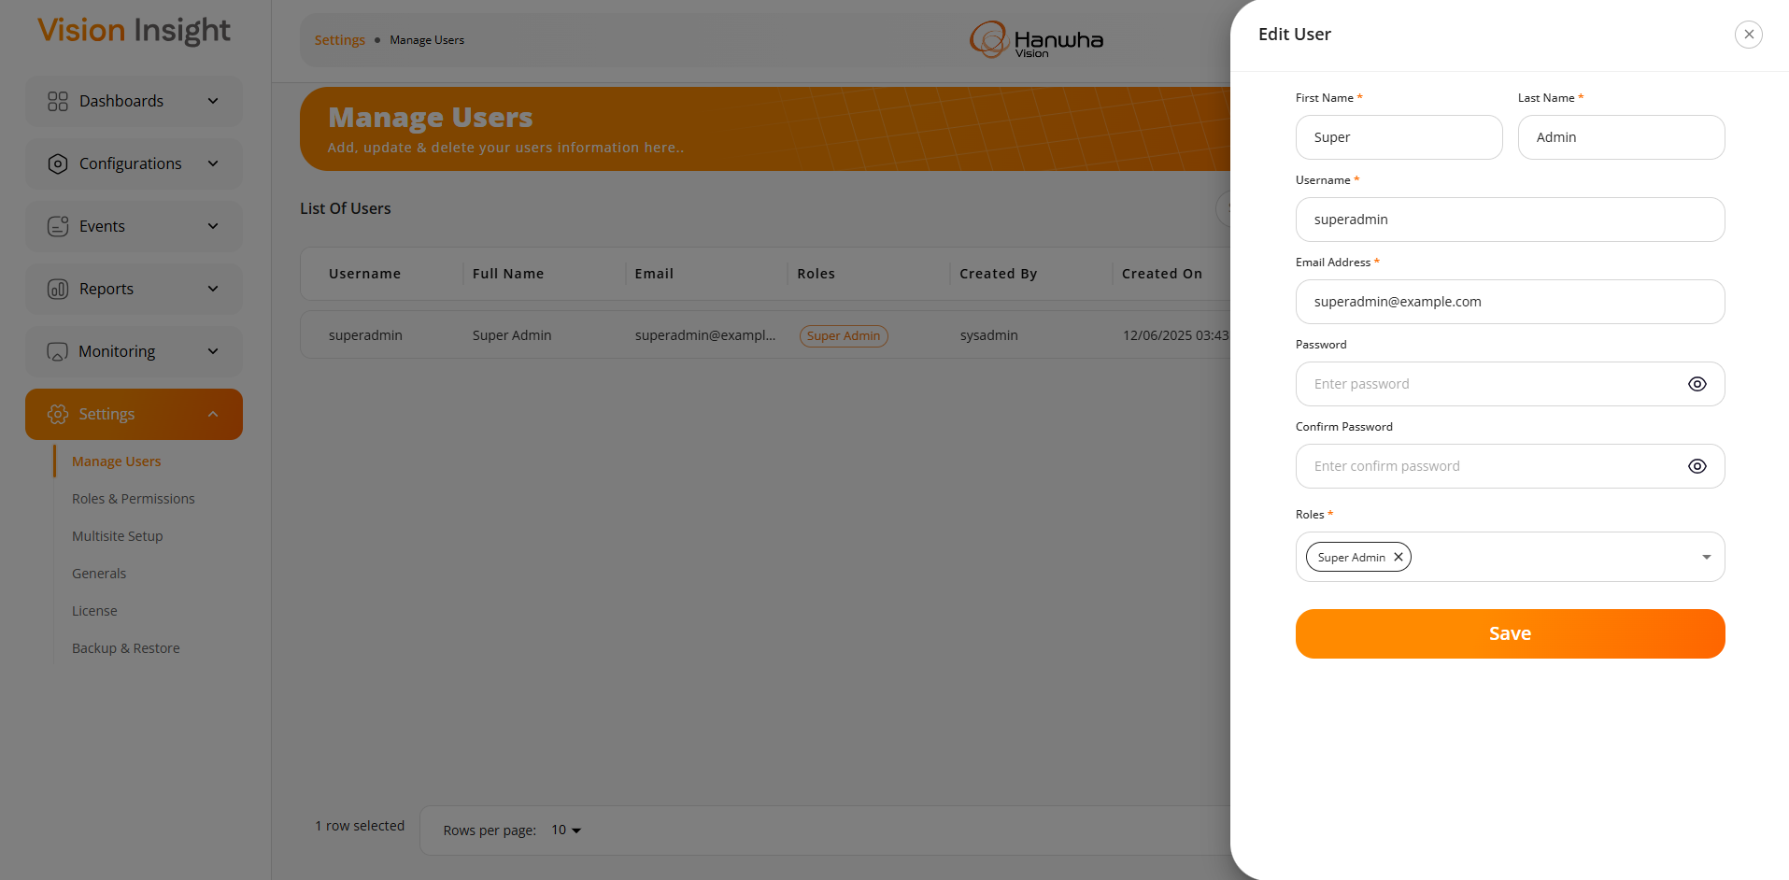
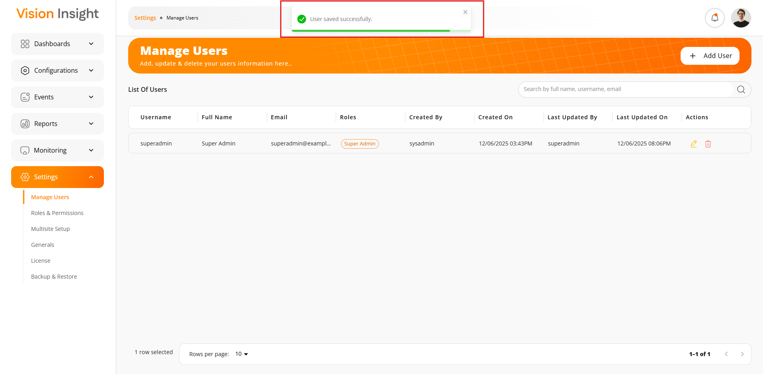

3) Role-based access control with permission management

A system will be in place to define different roles and assign specific permissions to each role. This allows for granular control over what actions users can perform based on their assigned role(s).

Screenshots:

- The screen below displays the list of all created roles, along with options to Search, Add, Edit, and Delete roles. The system will display an appropriate success message when a new role is successfully created, or existing role is successfully updated.
- Additionally, users can assign permissions at the Screens, Floor & Zones, and Widgets levels.
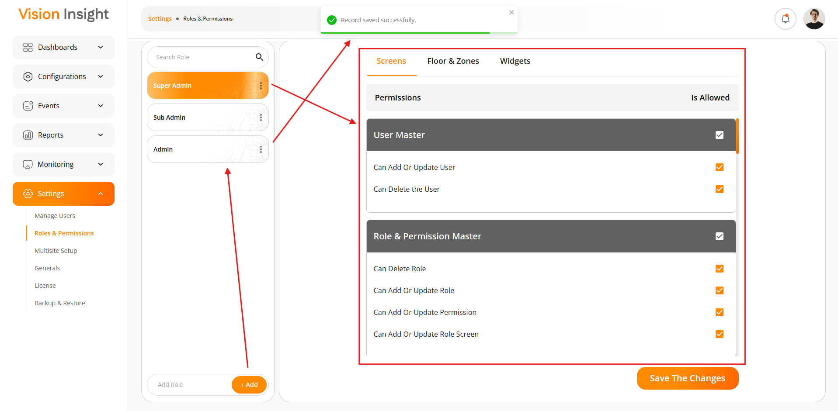
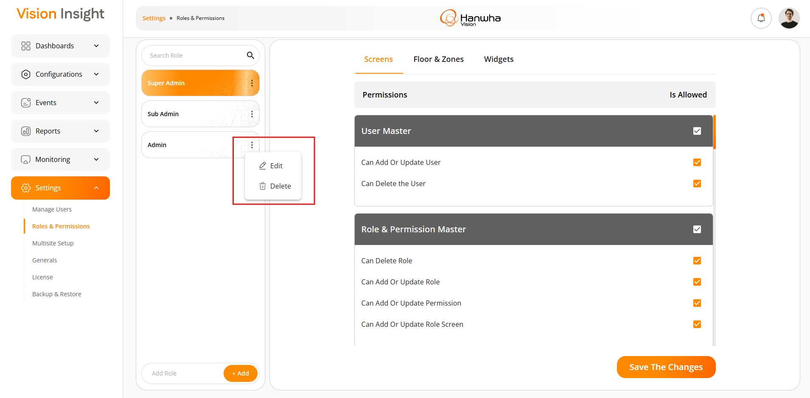
- When a user logs into the system, they will be able to access only those pages and functionalities that are permitted based on their assigned role permissions.
- In the image below, permissions have been assigned to the "Admin" role to access the following pages:
  - Dashboards
  - Manage Devices
  - Floor Plans & Zones
  - Manage Users
  - Roles & Permissions
  - Backup & Restore

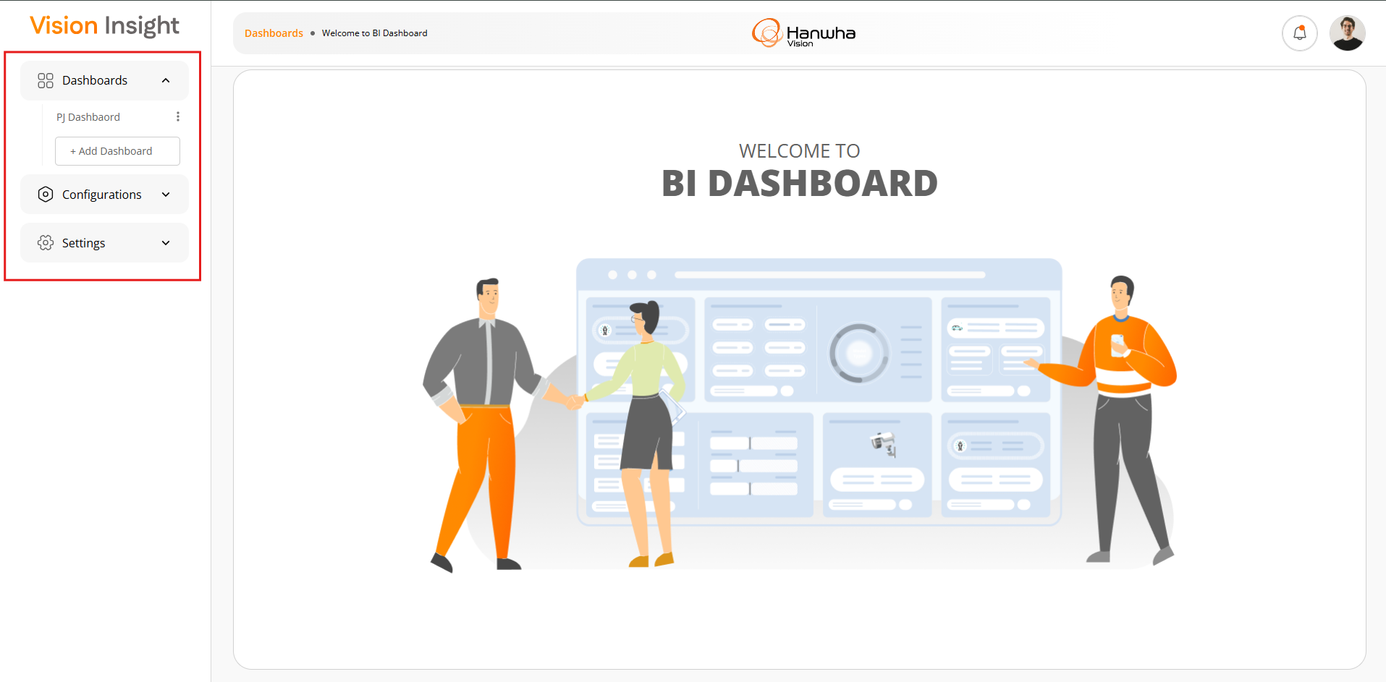
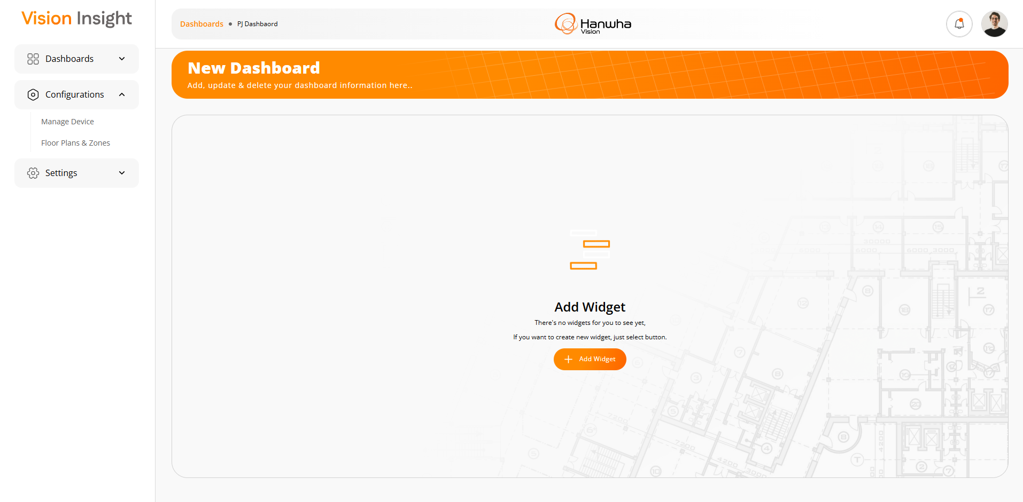
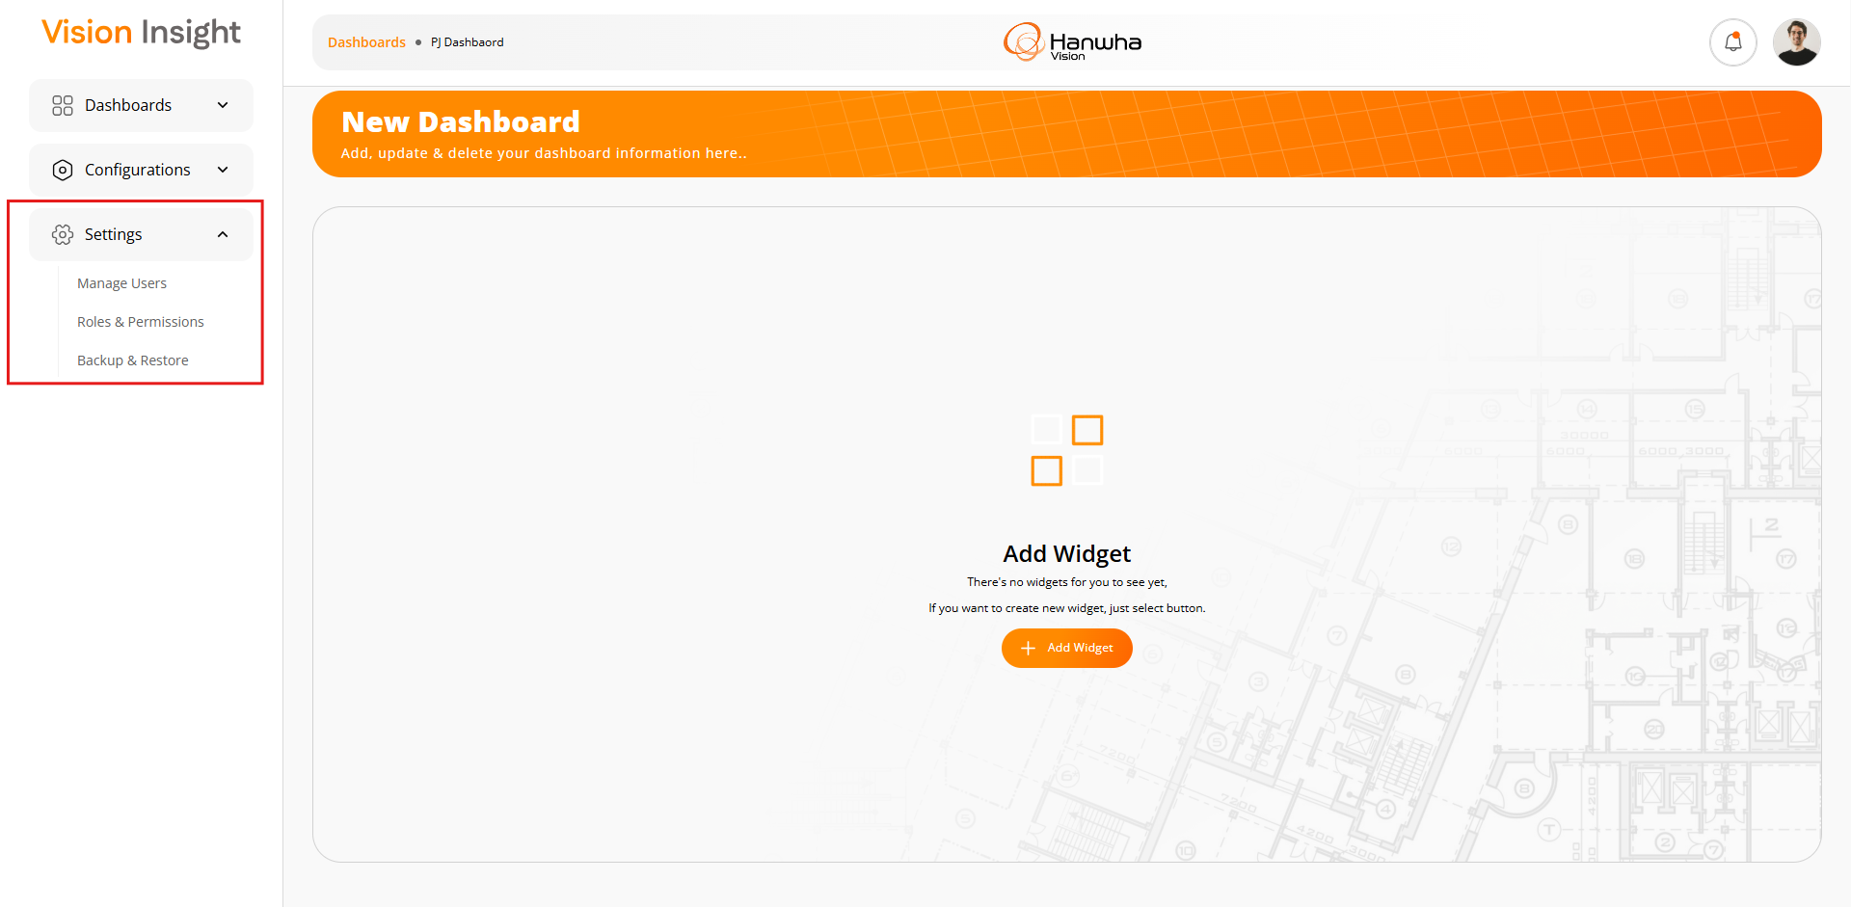

4) Functionality to manage camera devices and AI boxes

Authorized users will have the capability to create, modify, and delete devices like camera & AI Box.

Screenshots:

- The below screen will be displayed when no device is found in the system.
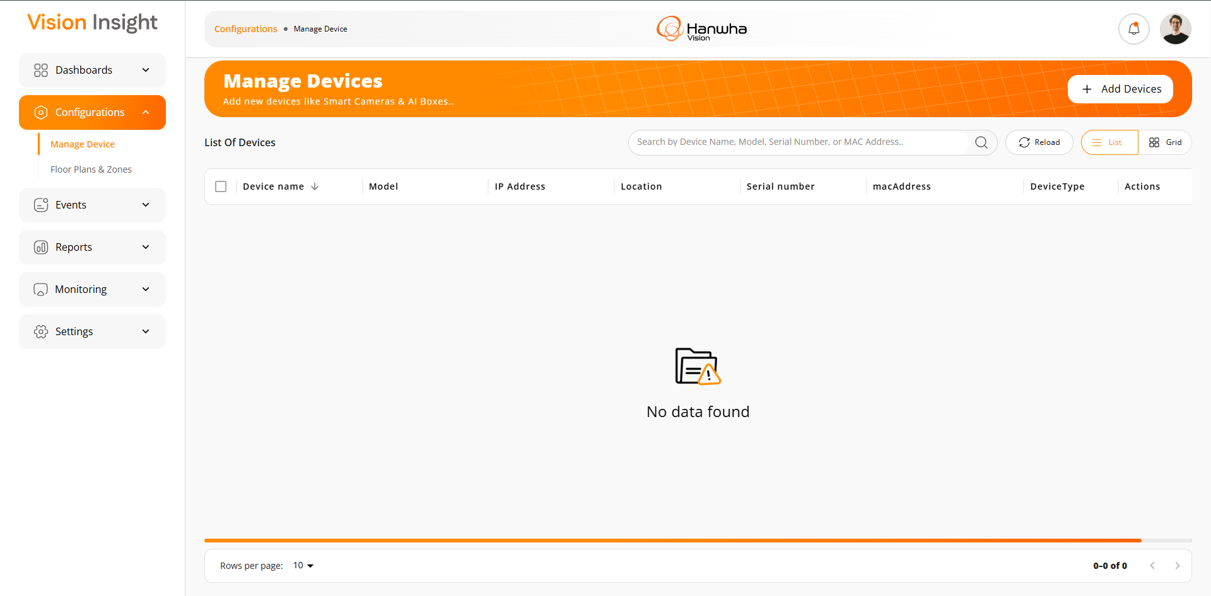
- The system will perform all necessary validations when adding a new device to ensure the entered information is valid and accurate.

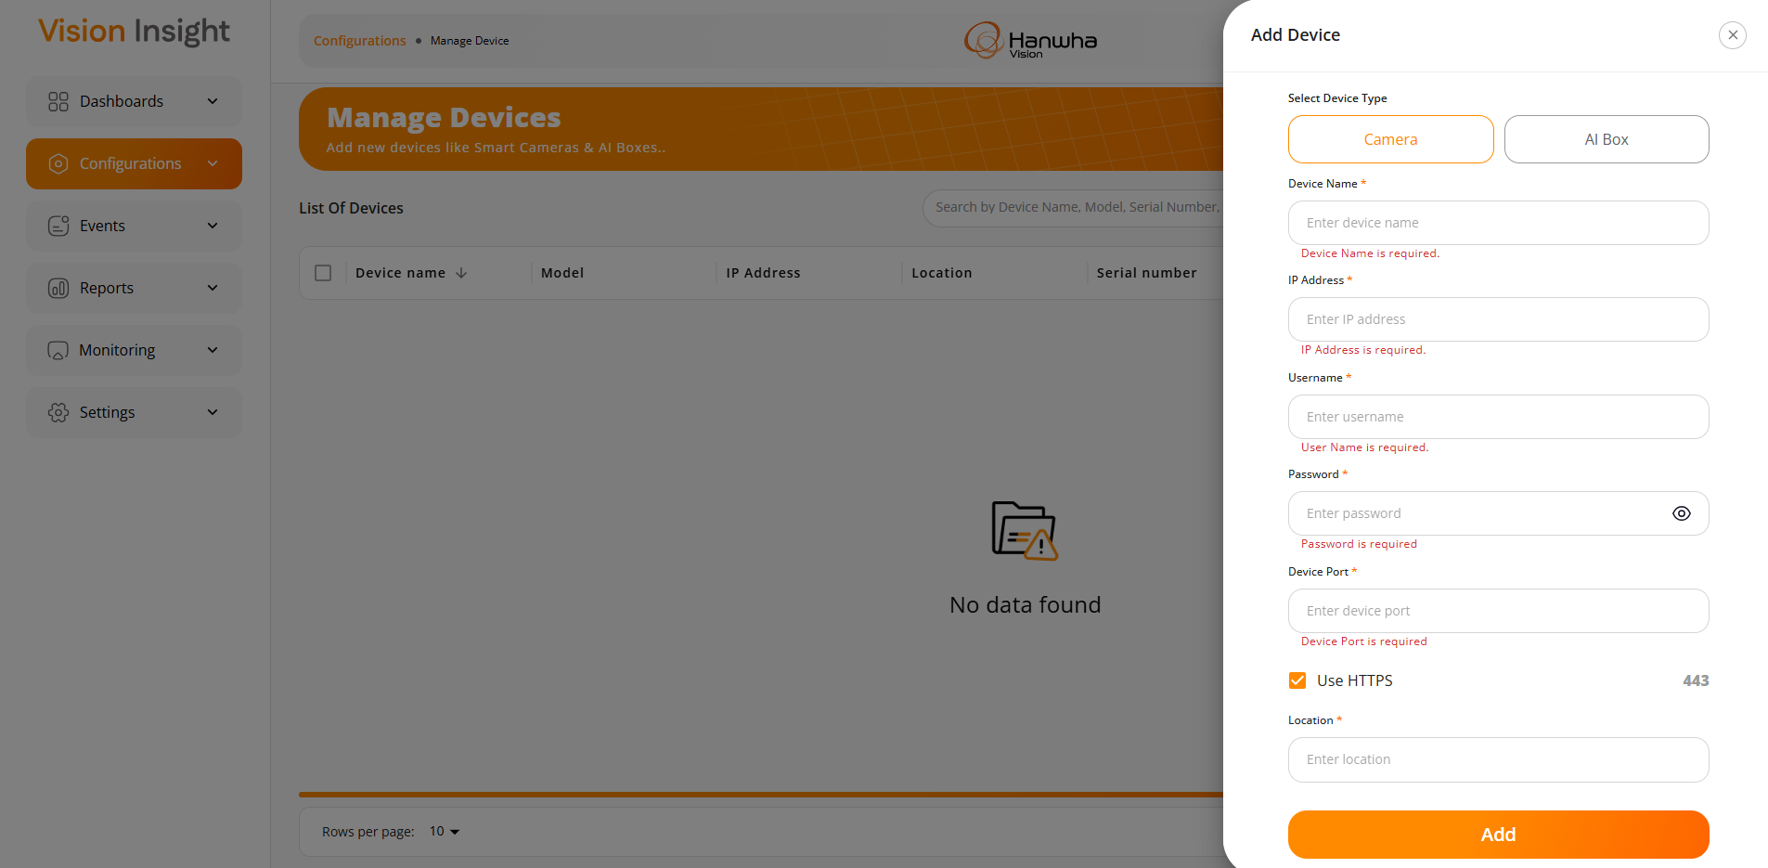
- The system will display the following success message when the device is successfully added to the system.
- While adding a new device (Camera or AI Box), the system will check the current availability of the device. If the device is available/online, it will be added directly to the system. Otherwise, the system will display the following message to the user:
“This device is currently unavailable or offline. Please verify the connection and try again”
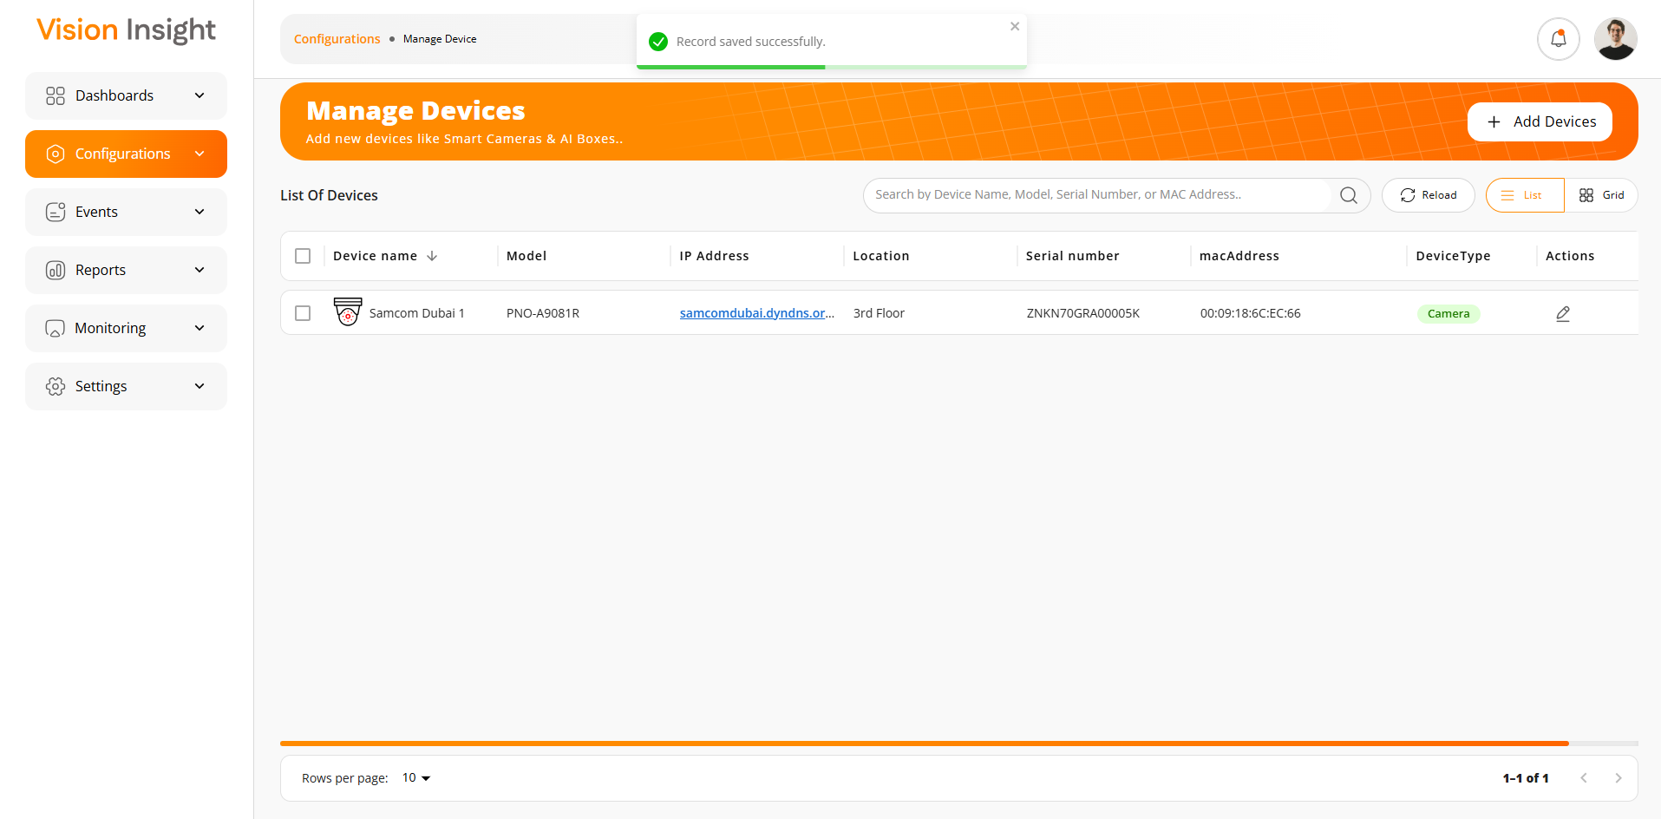
- The image below illustrates the grid view displaying all added devices in the system.
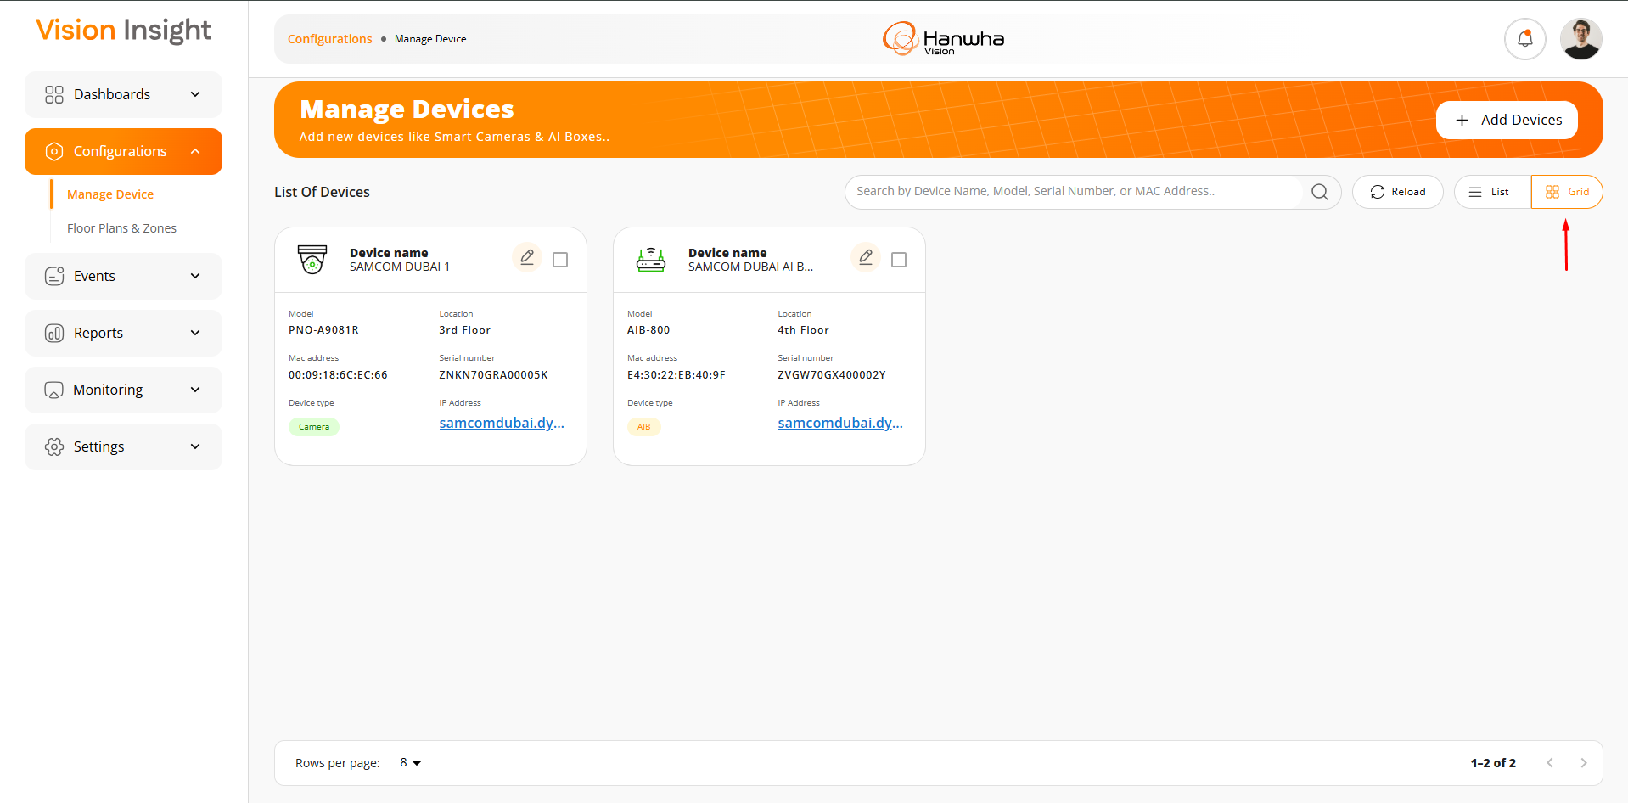
- The following fields will be displayed while adding an AI Box device to the system.
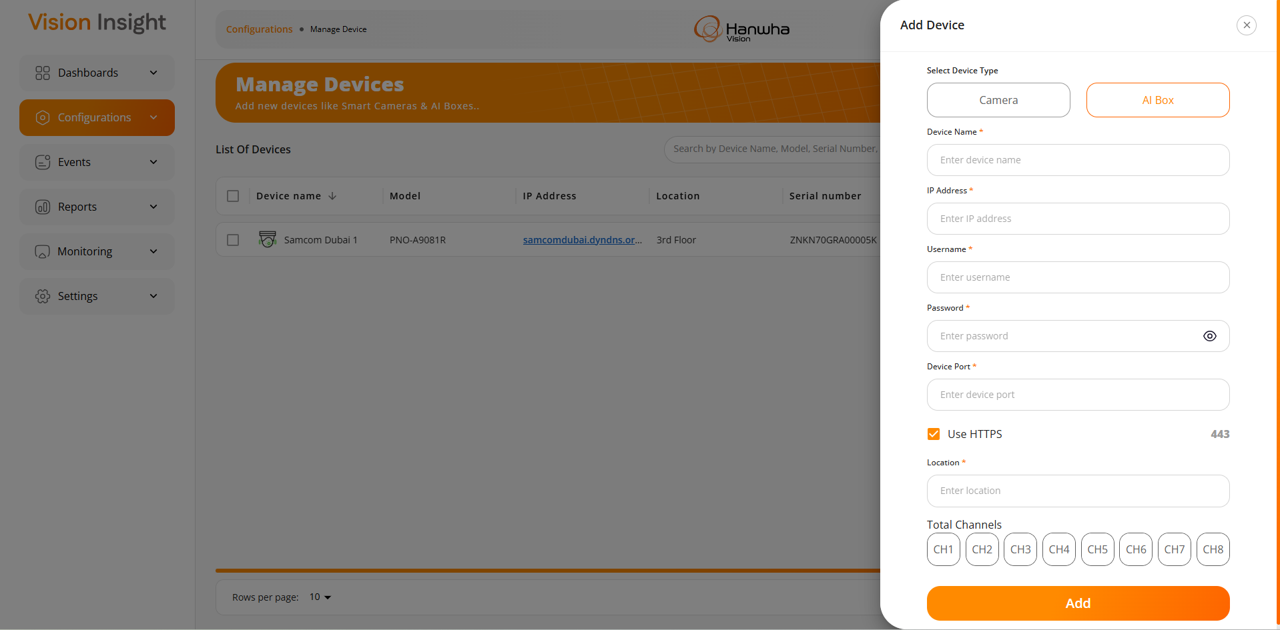
- The following fields will be displayed while adding an AI Box device to the system.
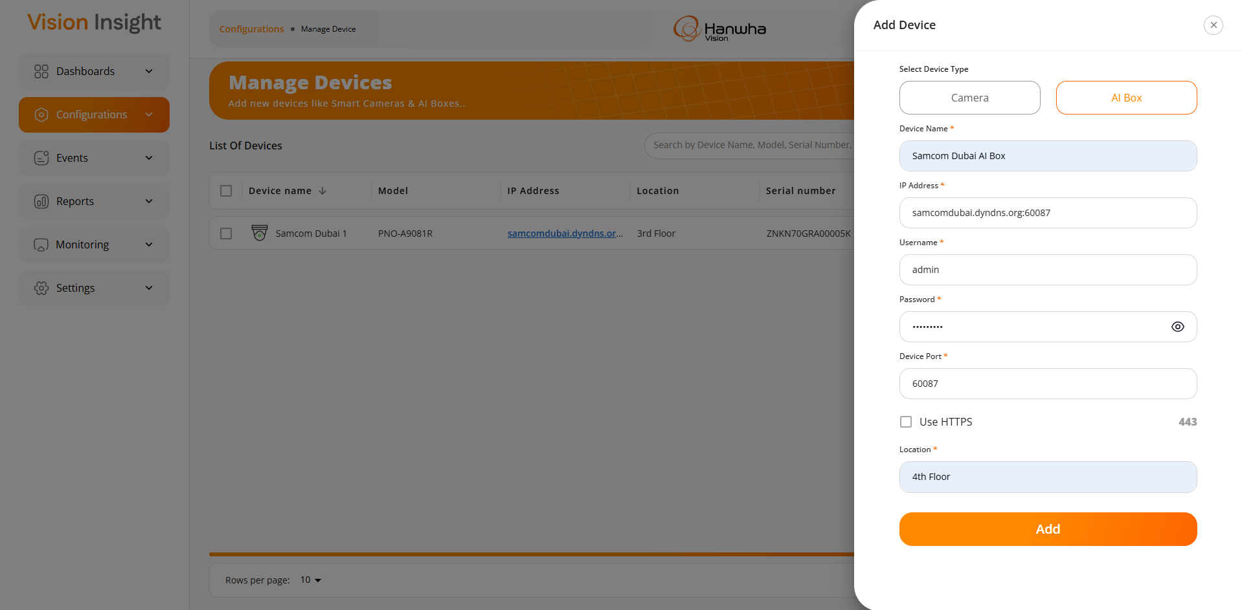
- The following fields will be displayed while adding an AI Box device to the system.
- The system will display online and offline devices as shown in the highlighted section of the screenshot below, so users can easily identify the device status directly from the Manage Devices page.
- If a device is online, it will be indicated in green color; if offline, it will be shown in red color.
- The system will make real-time API calls to check the current device status, and the updated status will be reflected on the screen accordingly when the user clicks the “Reload” button.

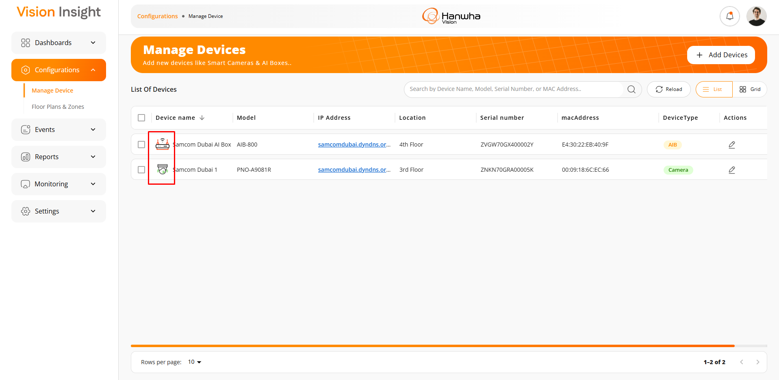
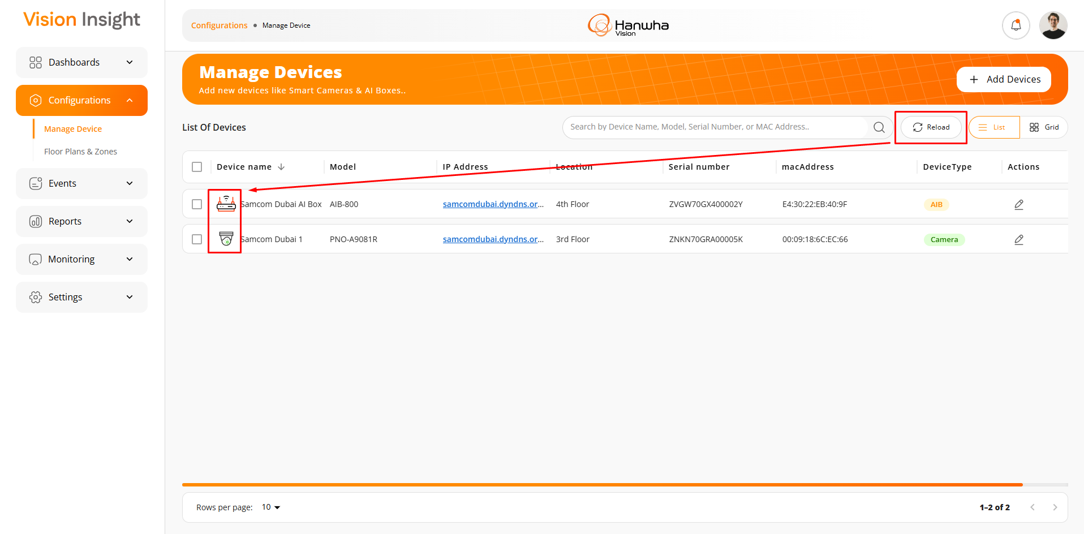
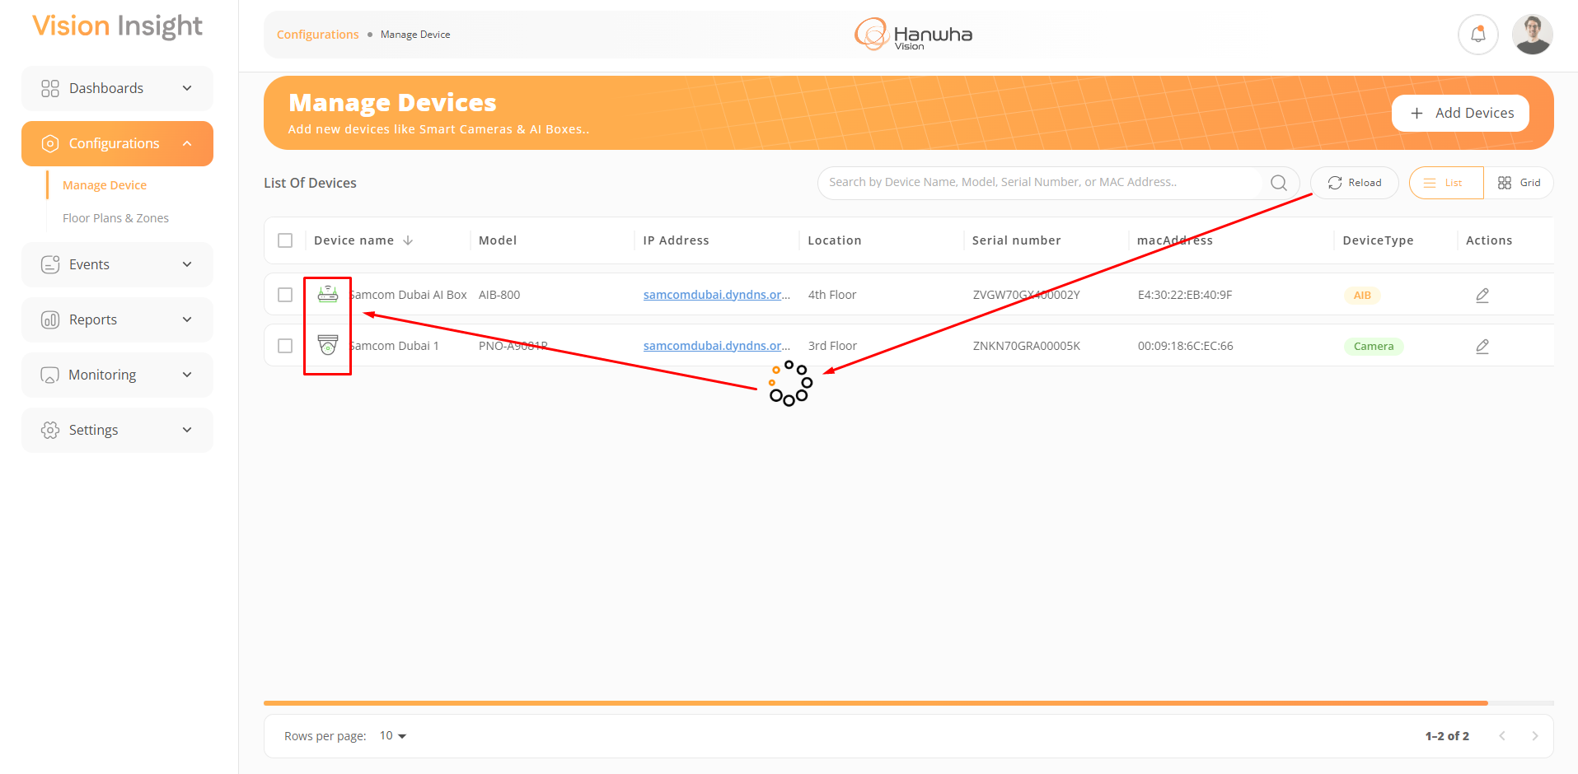
- Users can edit device information by clicking the Edit button from the list. The details shown below will be displayed for both Camera and AI Box devices.
- There is only one difference in the information displayed on the Edit form for Camera and AI Box devices:
  - The system will display the "Total Channels" field only for the AI Box, while this field will not be shown for Camera devices.
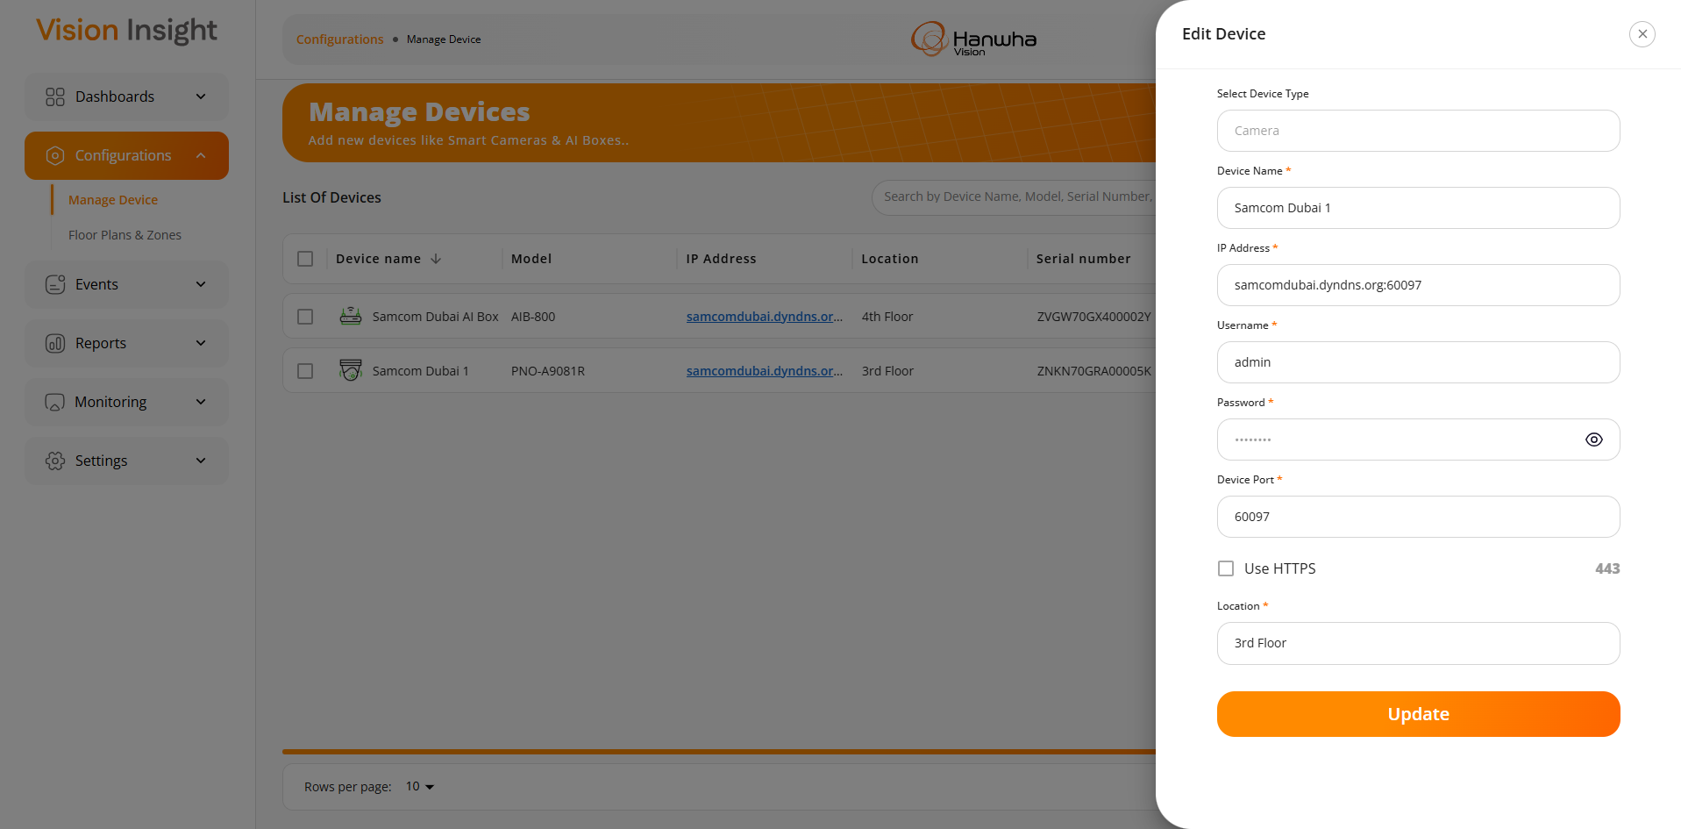
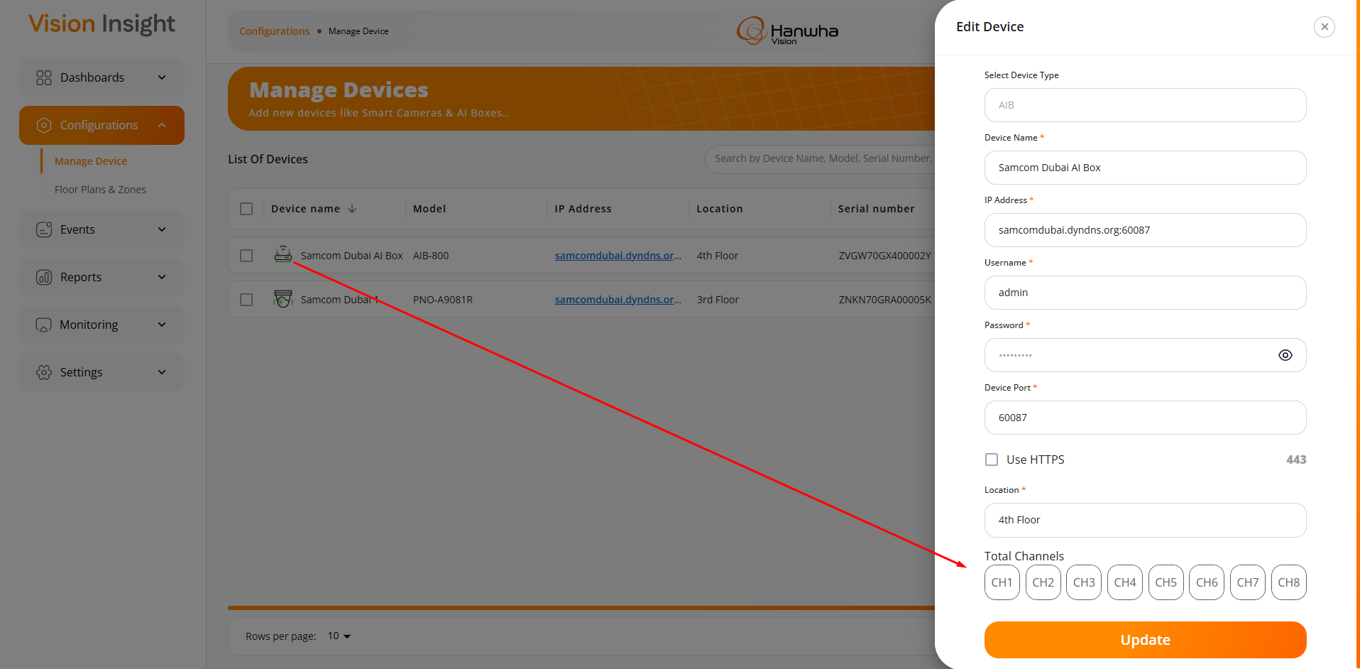
- The system will display the “Remove” button when the user selects any record by checking the checkbox from the list.
- Upon clicking the “Remove” button, the system will display a confirmation popup with a clear message to inform the user before removing the device from the system.
- Upon clicking the “Delete” button, the system will perform the action and display an appropriate success or failure message to the user based on the outcome.
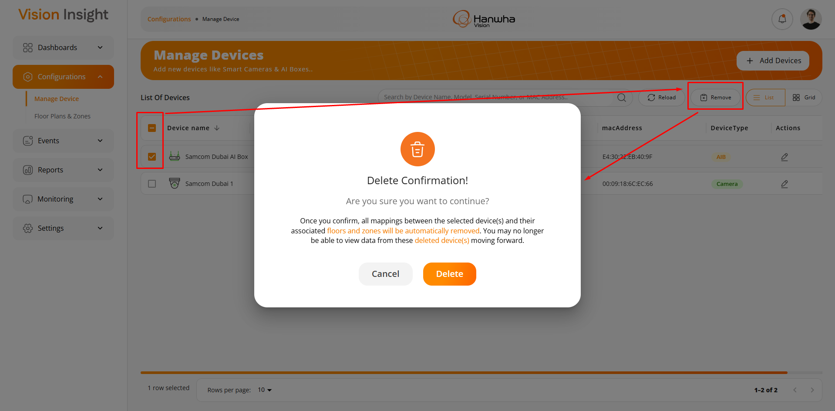

5) Floor plan and zone configuration capabilities & Mapping of cameras to designated zones

This feature includes the ability to manage floor plans, as well as to define and configure different zones or areas within those floor plans. Additionally, users can assign and configure camera devices to specific zones as needed.

Screenshots:

- The screen below will be displayed when no floor plan has been created in the system.
Users can enter a floor plan name in the text box and click the “+ Add” button to initiate the first floor plan with any desired name.
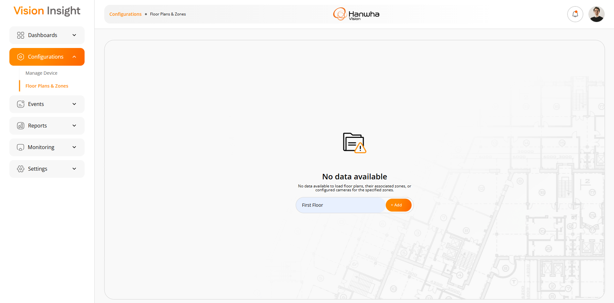
- The user will be redirected to the screen below after entering the floor plan name on the previous screen.
- The system will display an appropriate success or failure message based on the response received after submitting the request.

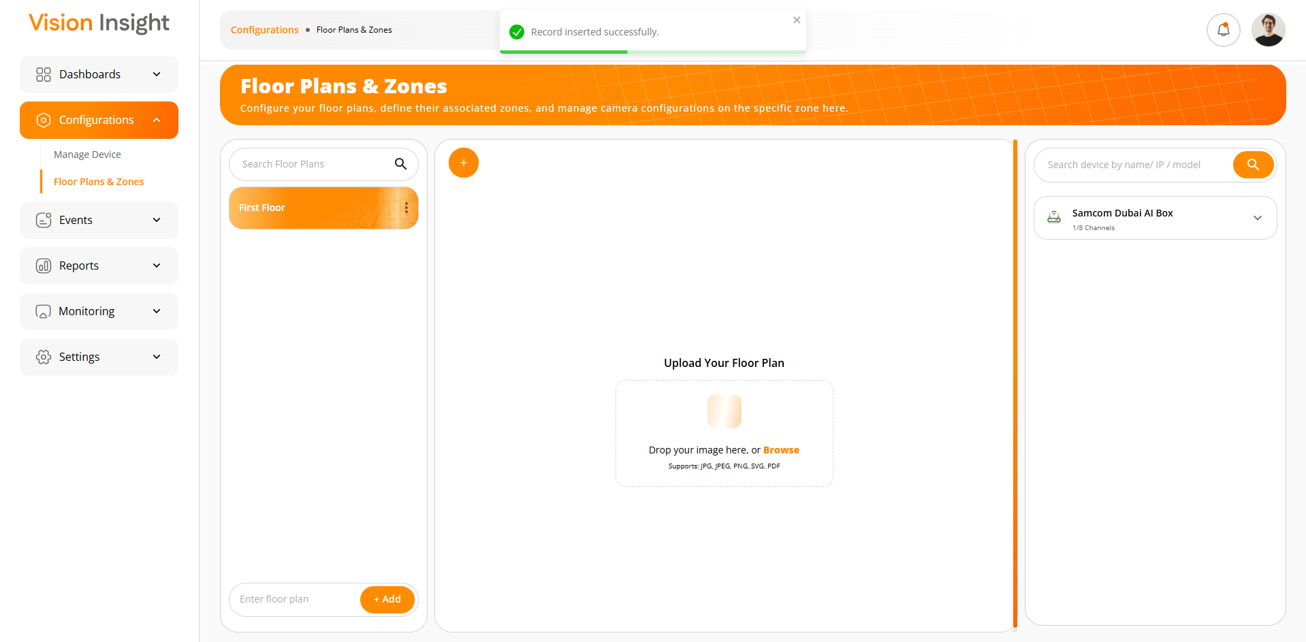
- The screen below displays a list of all created floor plans, along with options to Search, Add, Edit, and Delete.
- On the right side, the system shows all online AI Boxes with their associated camera devices, including those configured in the system from the “Manage Devices” screen.
- It also includes the option to view associated active lines of a specific camera device and filter data based on Device Name, IP Address, and Model Name
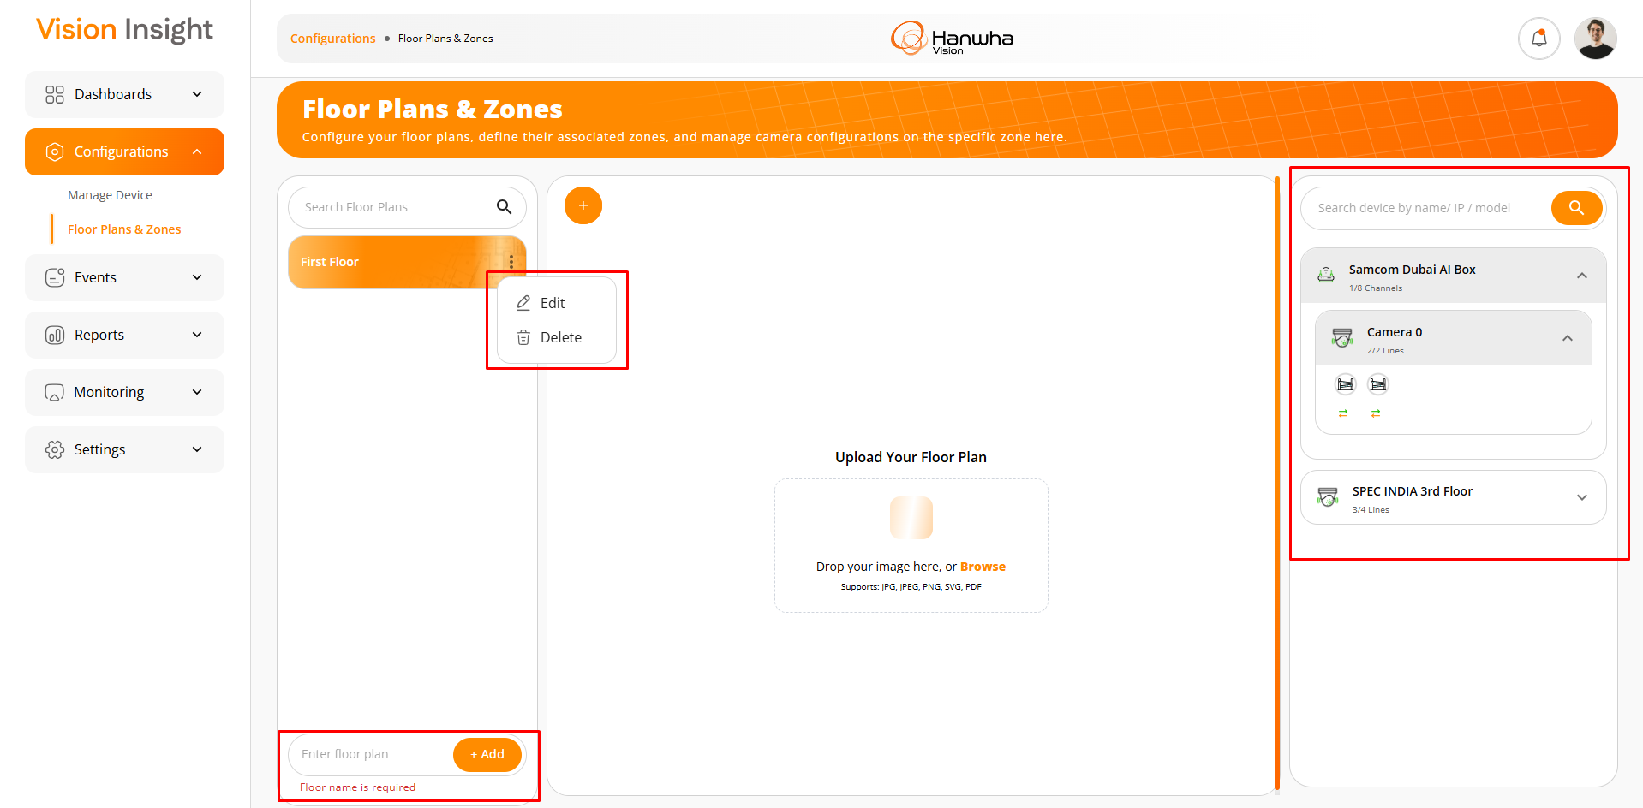
- The screen below displays the form used to create a new zone with the necessary fields on a specific floor plan.
- The system will validate the entered information and display appropriate messages when required fields are missing or incorrect.

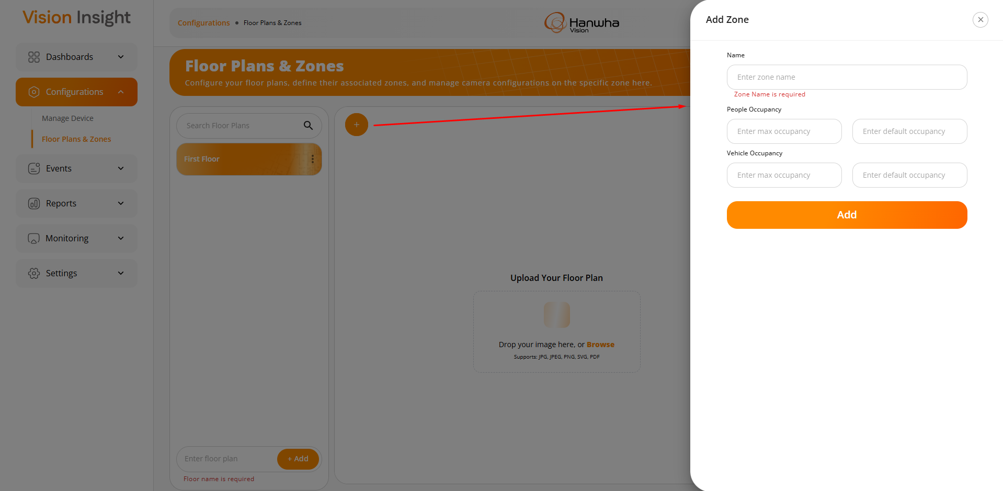
- Once the user fills in the necessary details in the “Add Zone” form, the system will submit the information and display an appropriate success or failure message based on the result. If the zone is successfully added, it will then be displayed in the list of existing zones.
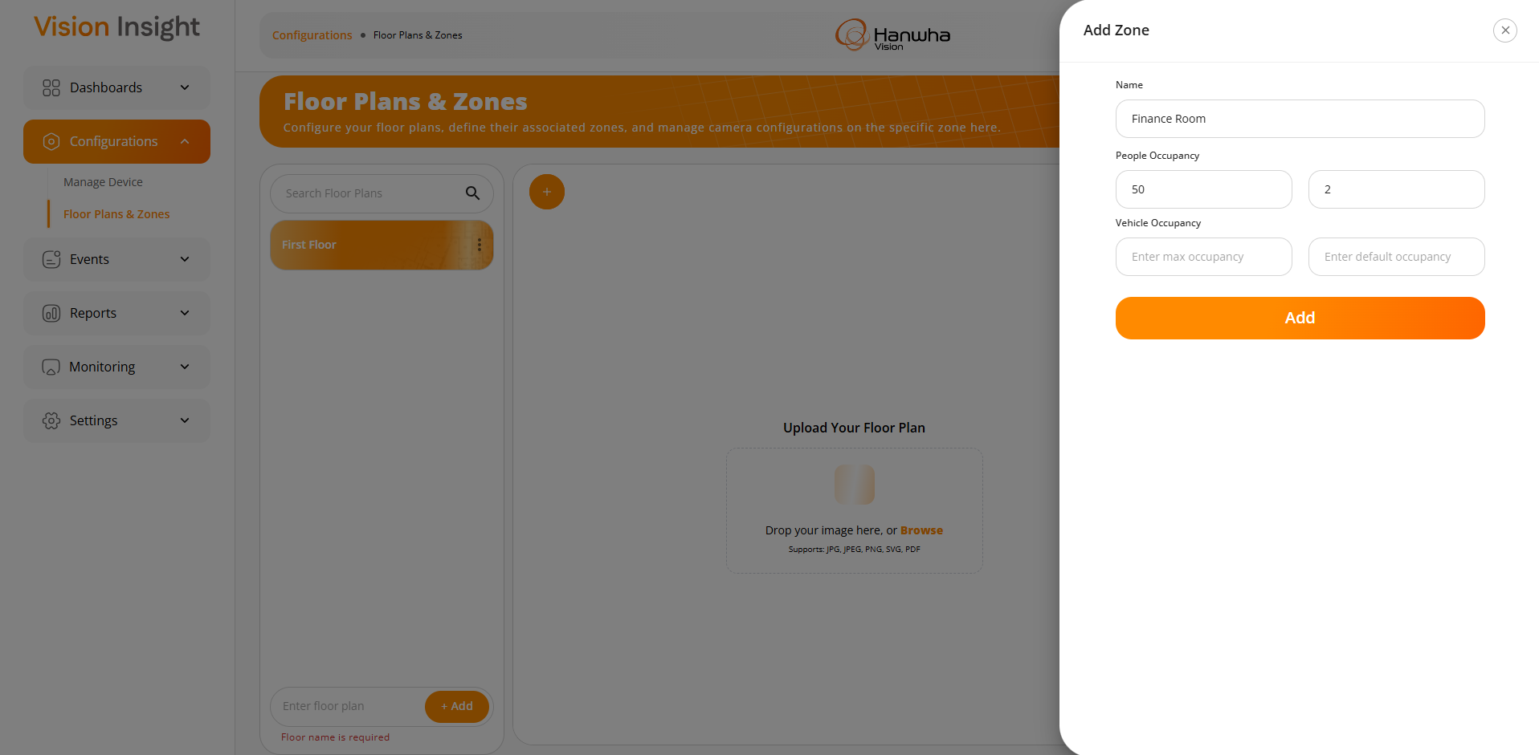
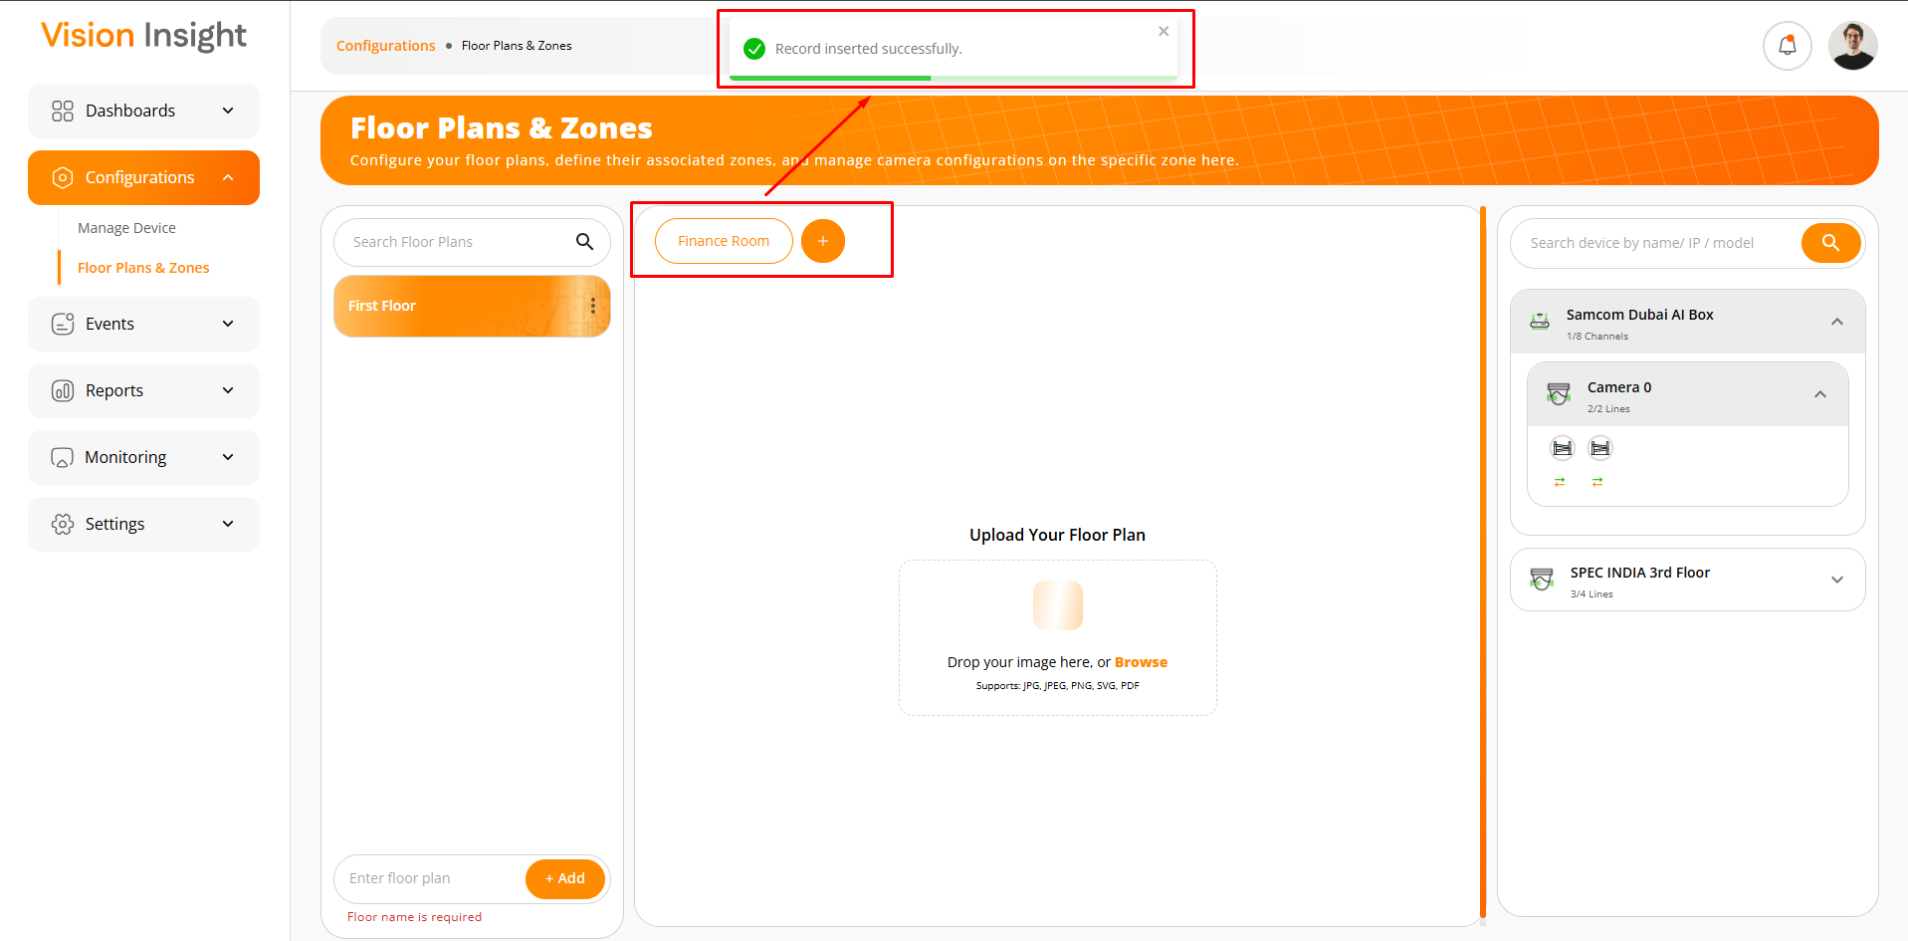
- Users can edit or delete zones by clicking on the highlighted buttons shown below.
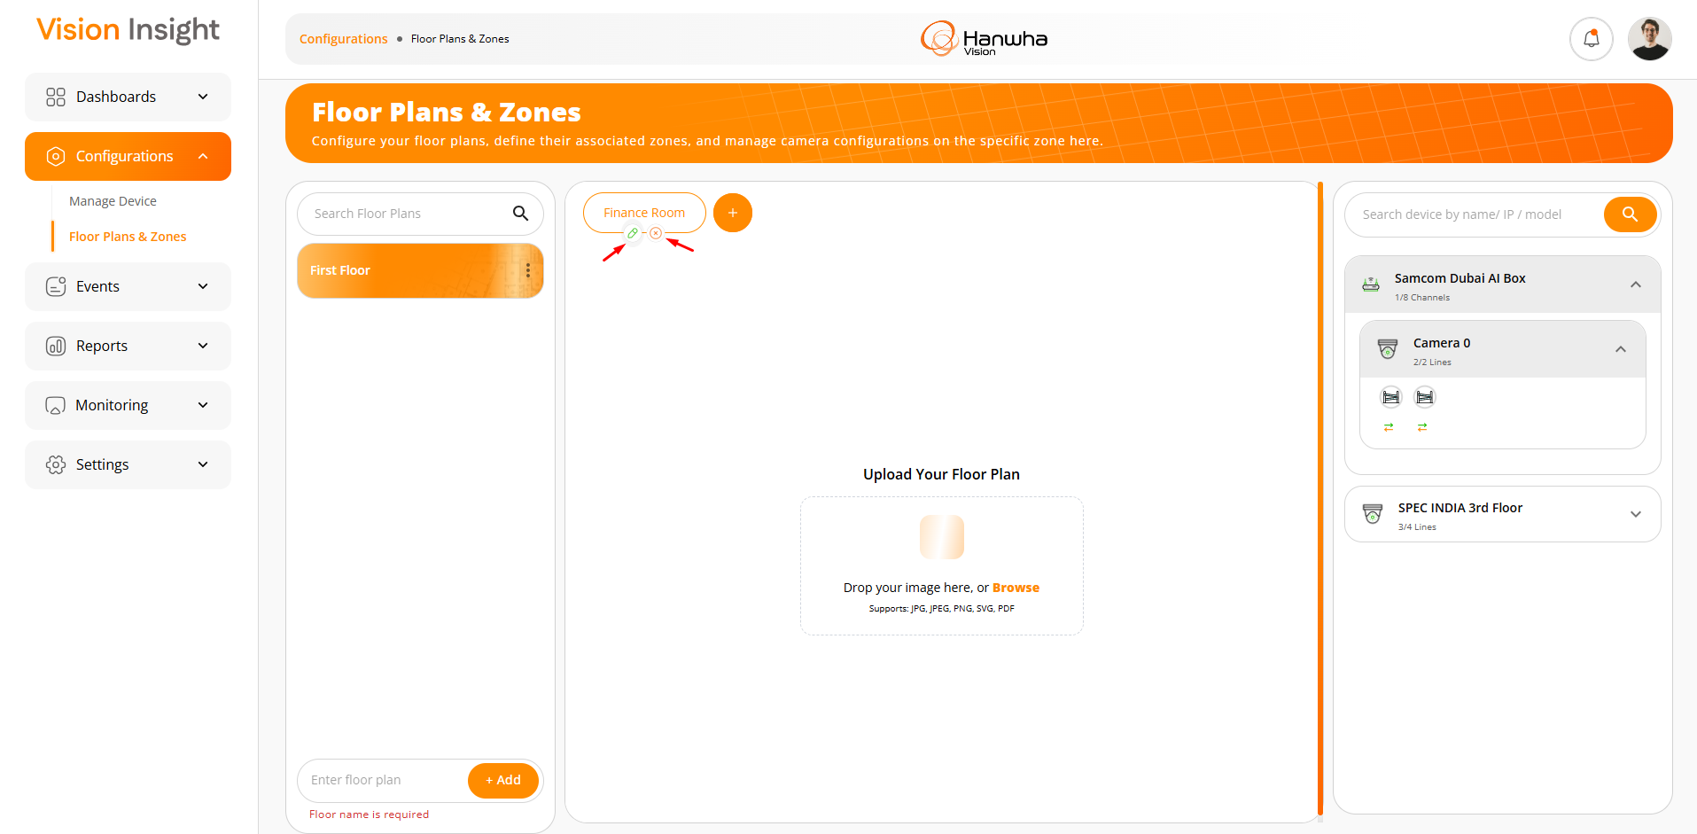
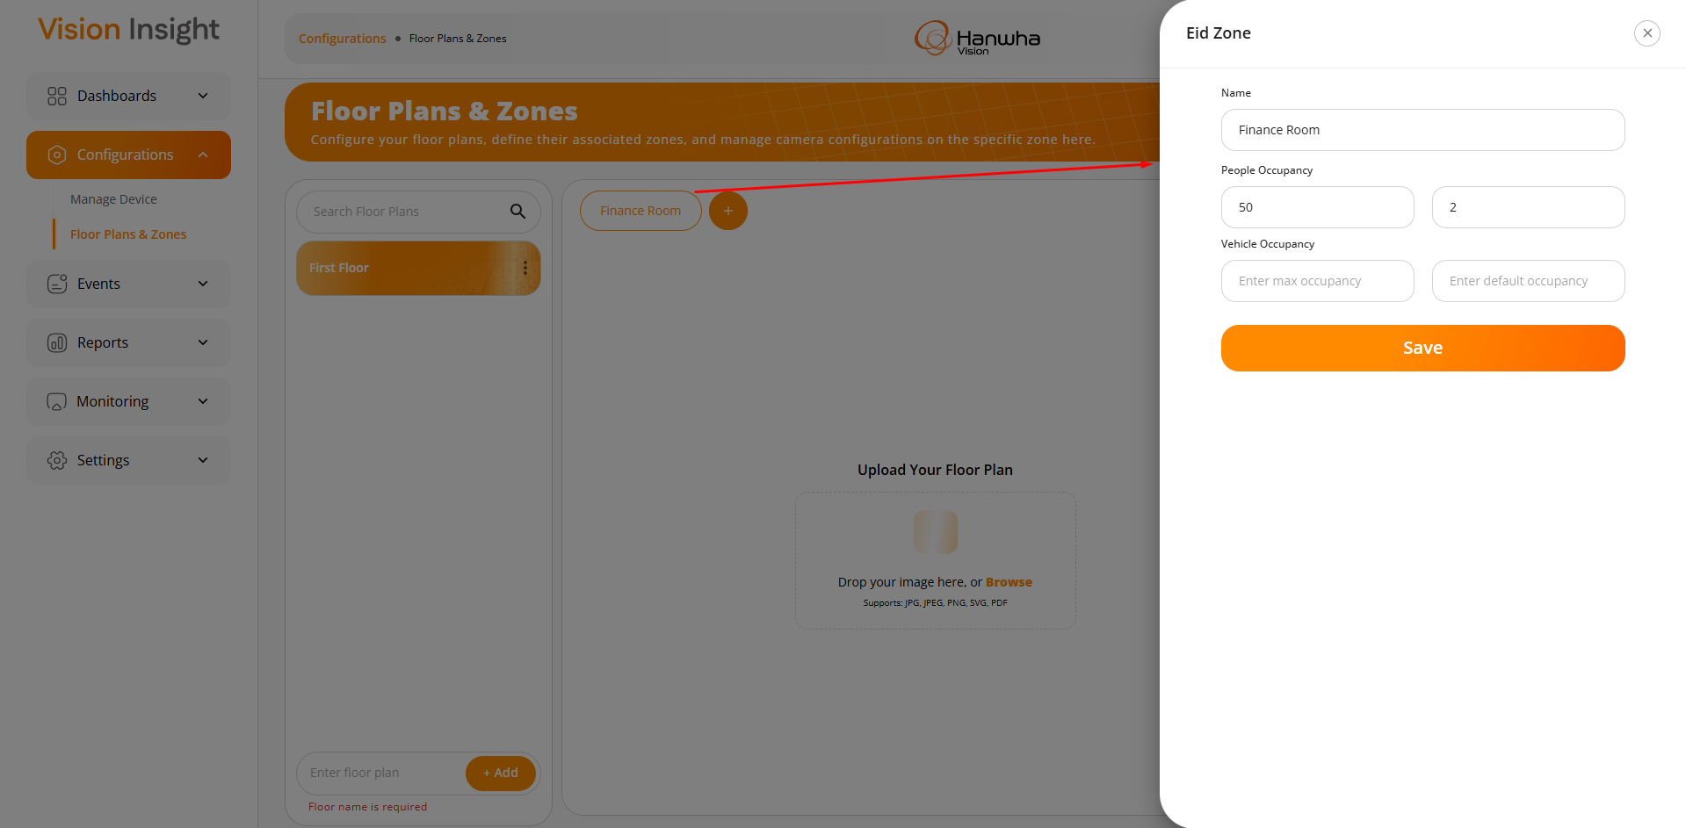
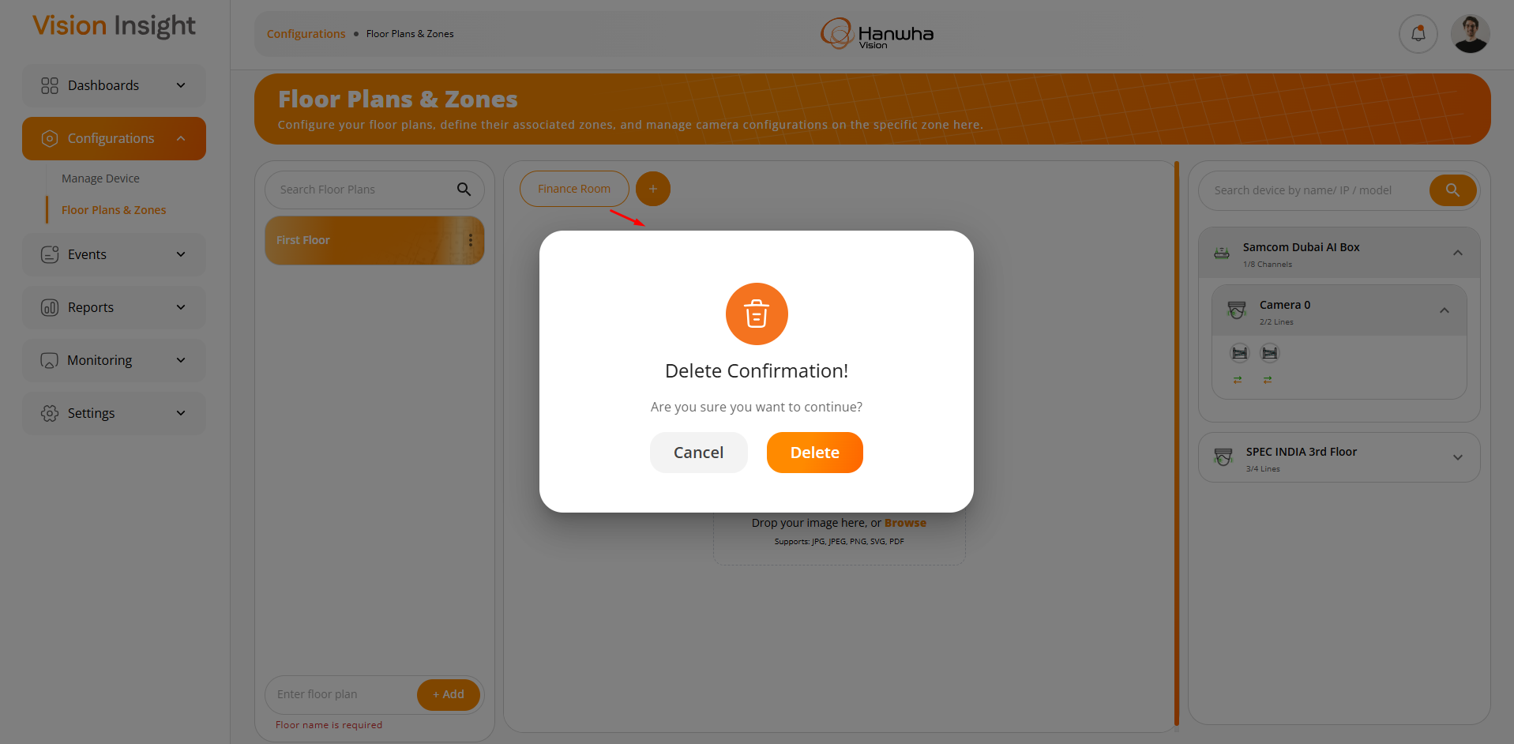
- Upon clicking the highlighted area below, users will be able to upload a floor plan image in the following supported formats: PNG, JPG, JPEG, SVG, and PDF only.

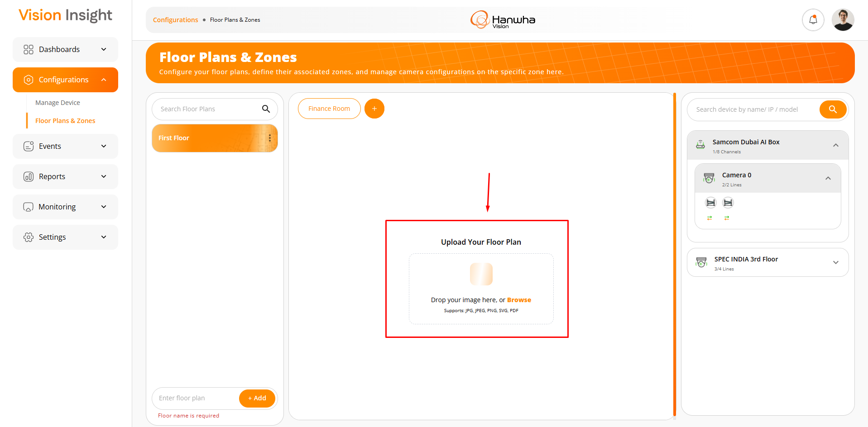
- The system will display an appropriate success or failure message upon uploading the floor plan image, based on the response received.
- After successfully uploading the image, the system will display the following options:
  - Replace Floor: Allows users to replace the floor plan image at any time.
  - Save Changes: Saves all updated changes. Users must click this after modifying any details on the floor plan image.
  - Draw Zone: Enables users to draw zones directly on the floor plan image.
  - Zoom In & Out: Allows users to zoom in and out of the floor plan image within the specified area.
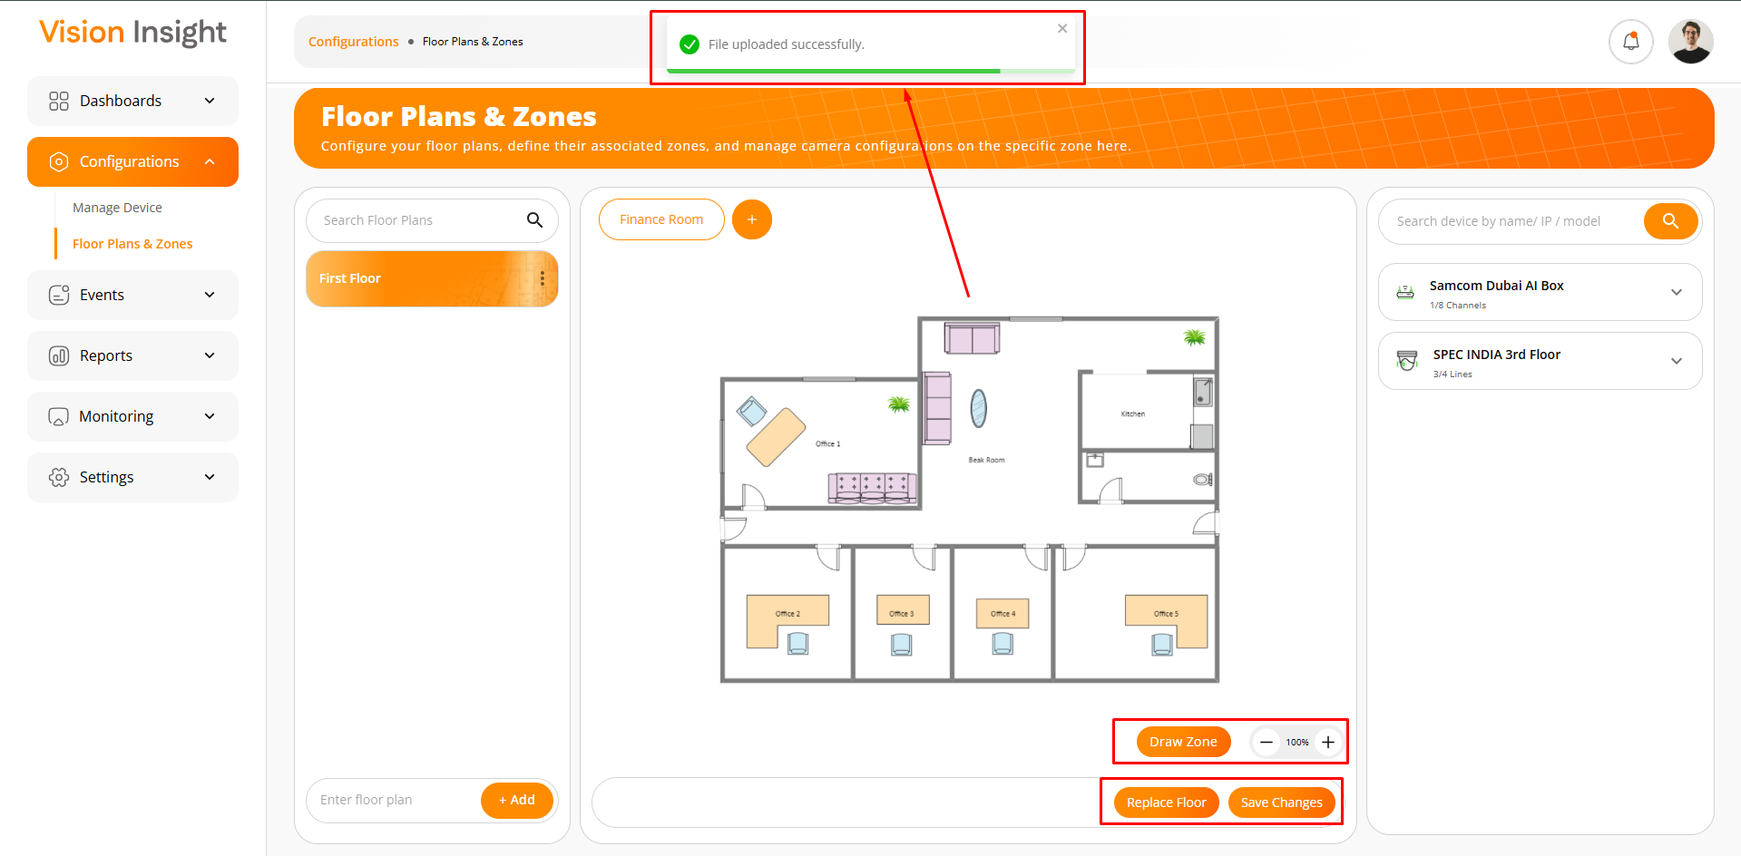
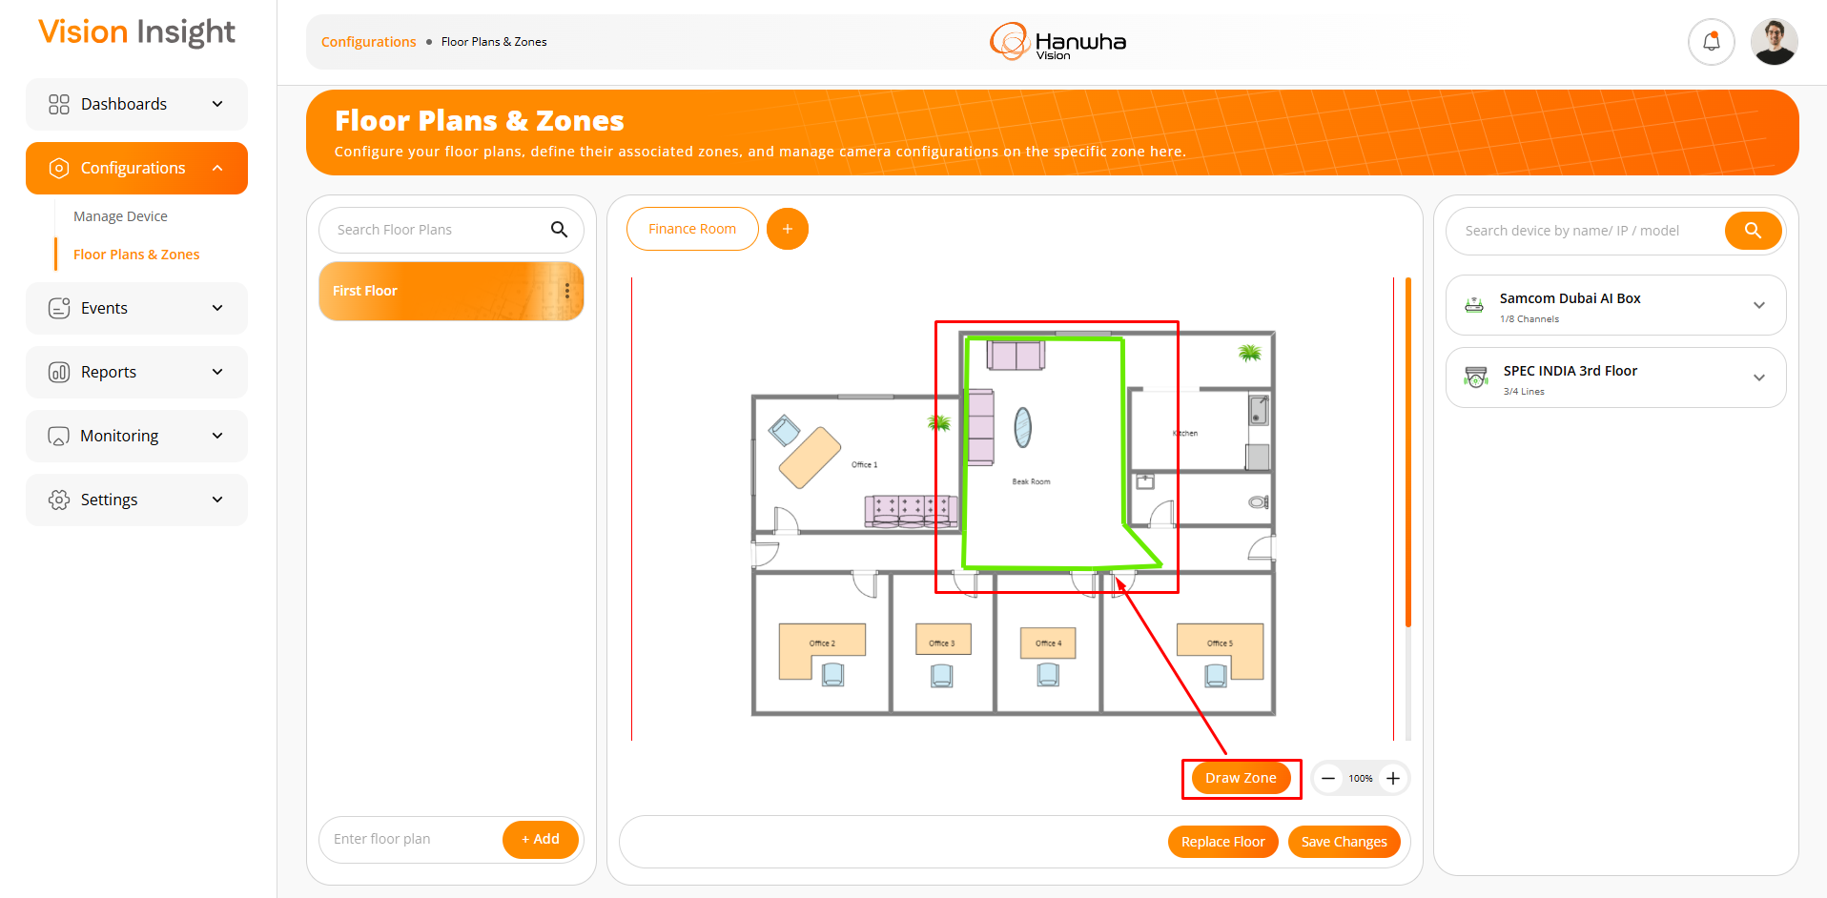
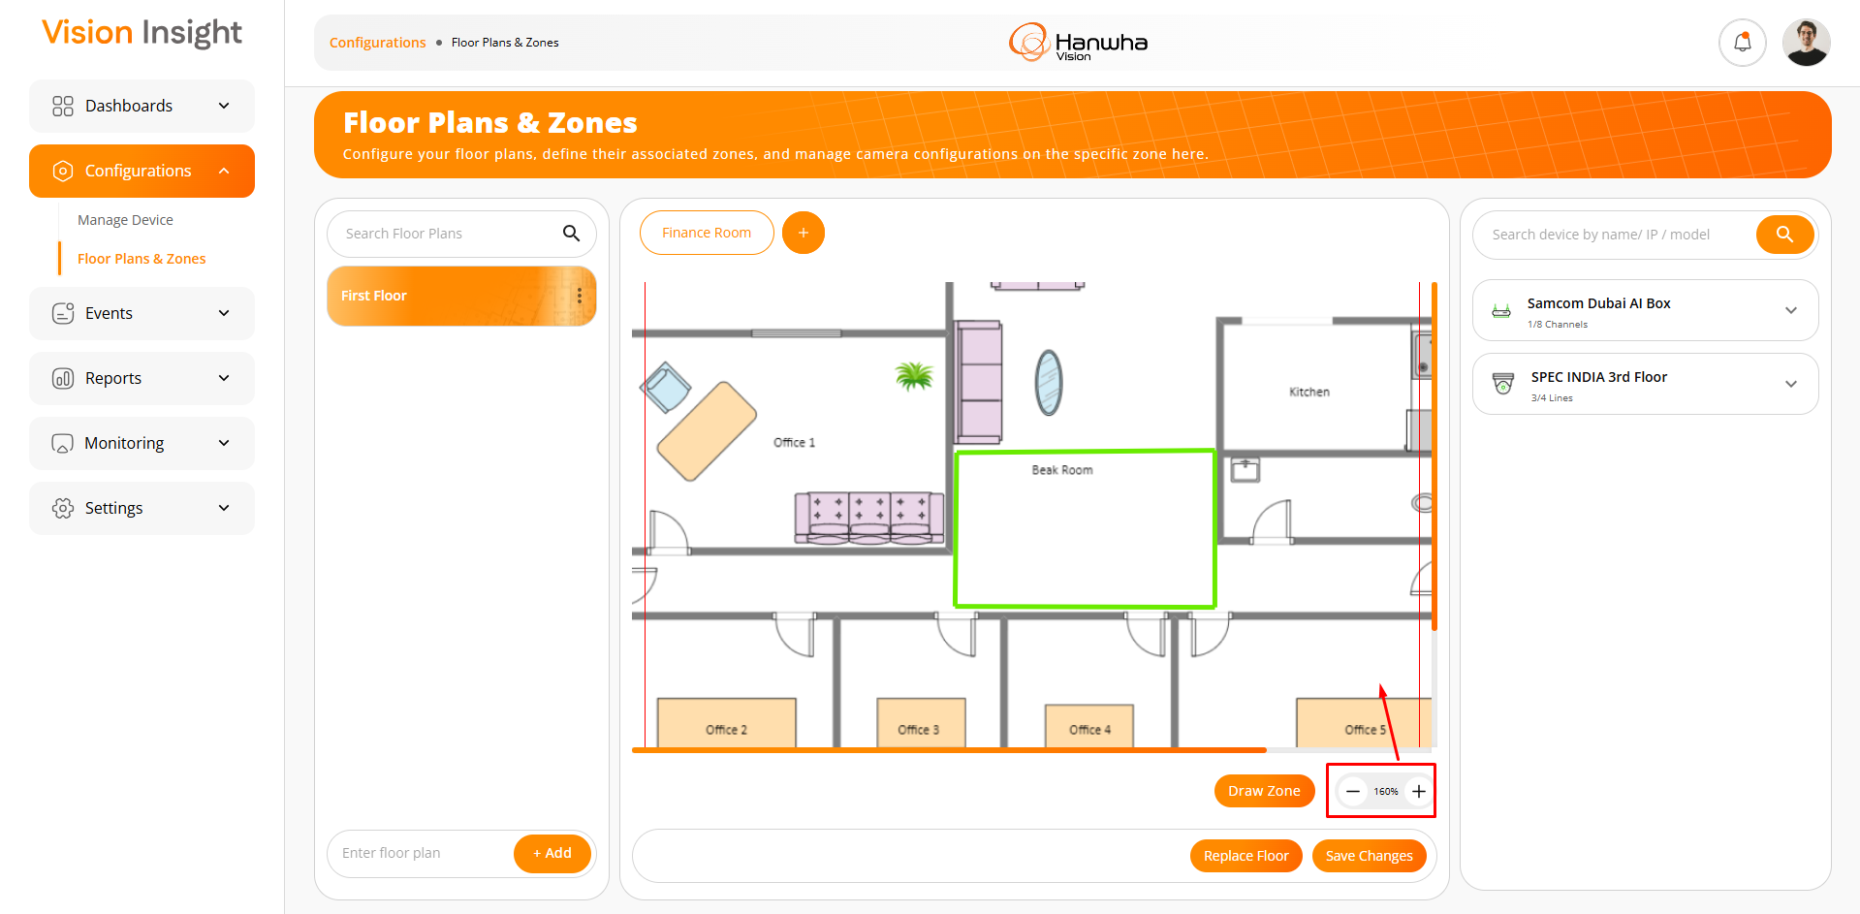
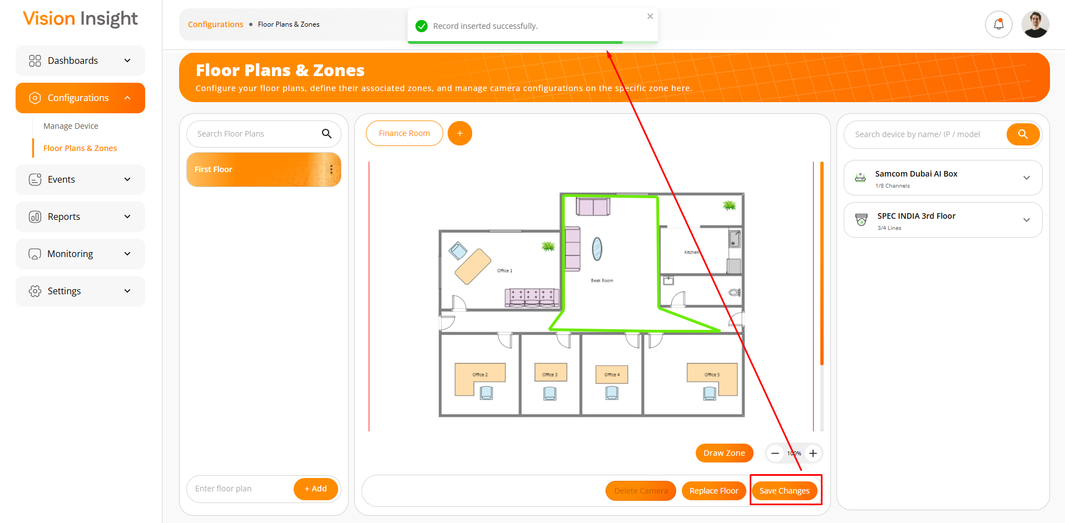
- The screen below illustrates the camera configuration options for a specific zone under a selected floor plan.
- Users can perform the following actions:
  - Drag & Drop a camera from the right-hand side active camera or AI Box list, selecting the number of line(s) to be configured for the specific camera.
  - The system will display the associated floor plan and zone name when the user hovers over a specific line of a camera in the list.
  - Rotate the camera as needed.
  - Select between “Focal” or “Sphere” modes.
  - Apply custom colors to the selected Focal or Sphere area.
  - Use the option to delete a camera from the configured plan.
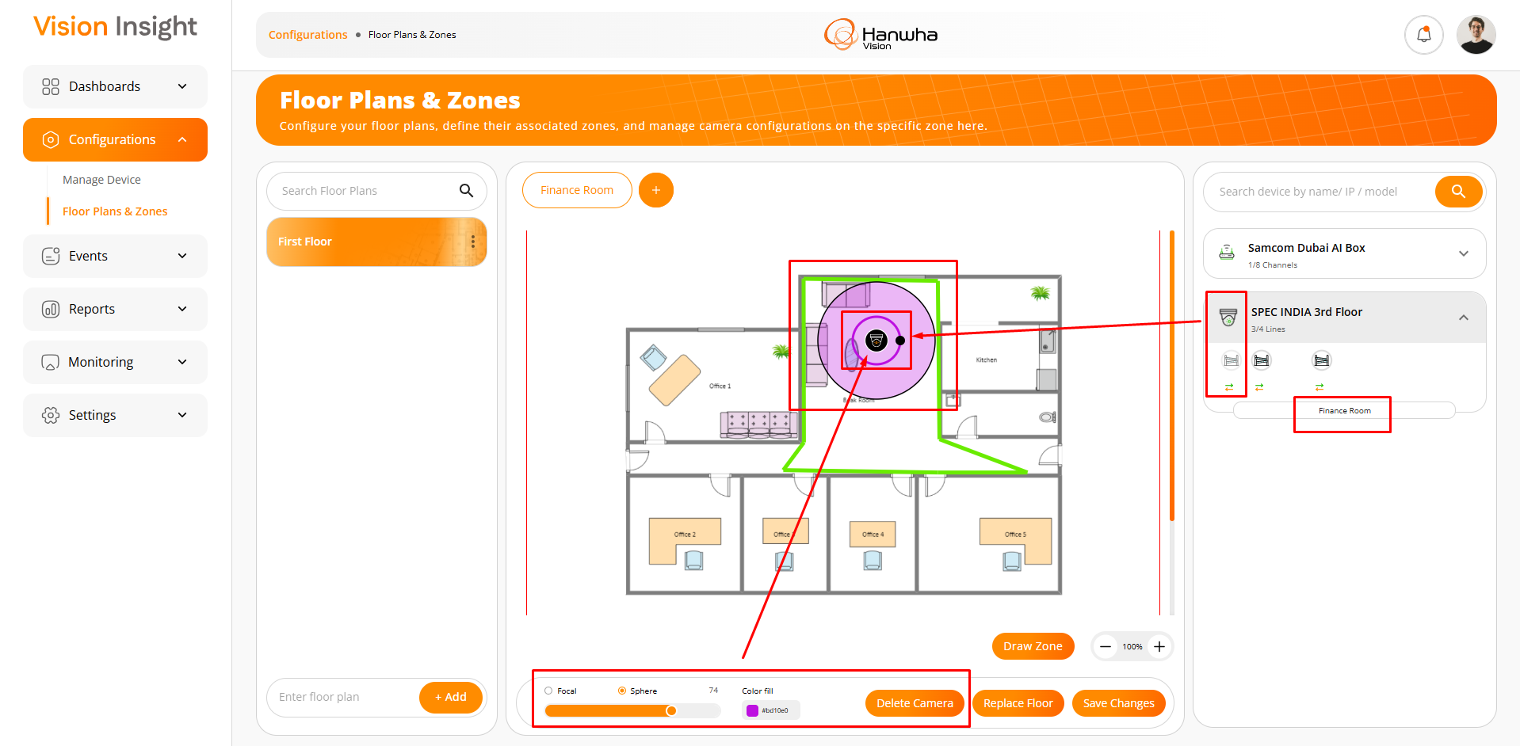

- The system will display a confirmation popup when the user attempts to delete a camera by clicking the “Delete Camera” button.
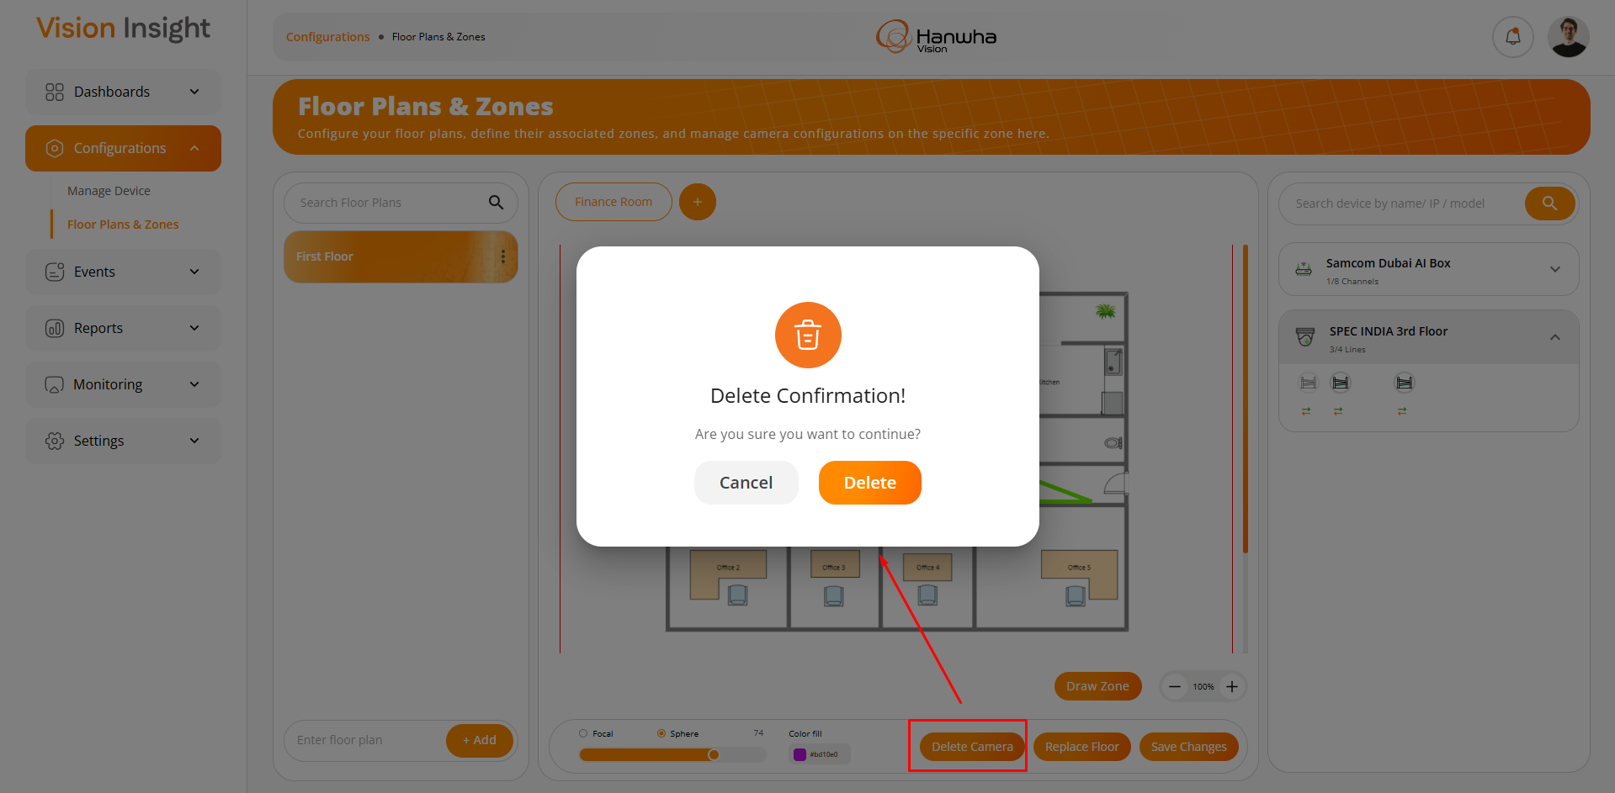

6) Support for managing multiple sites

The system allows the parent site’s authorized / super admin users to manage single or multiple child and sub-child site configurations.

Screenshots:

- The screen below will be displayed when there is no data found in the system.
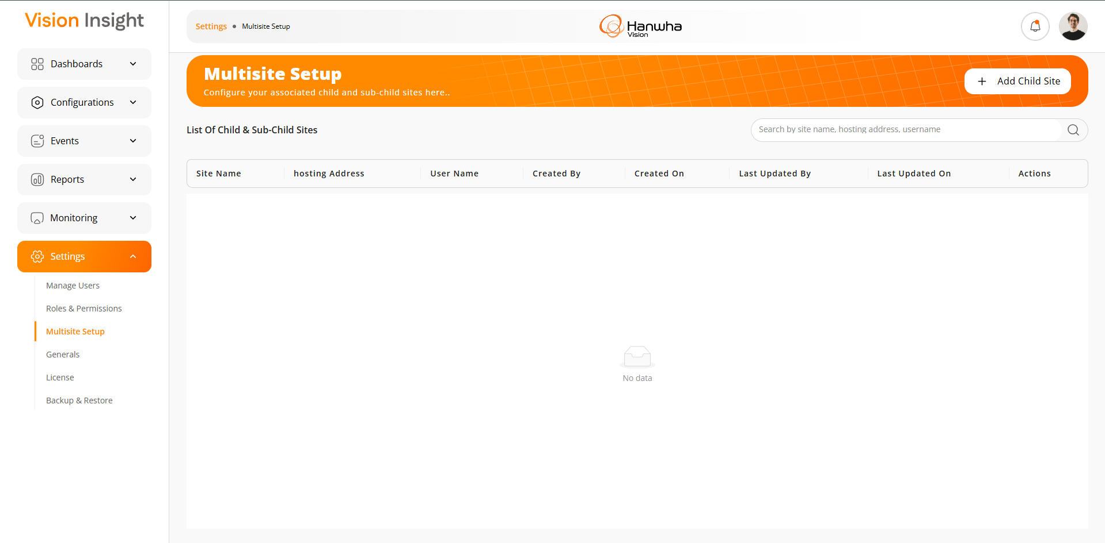

- The screen below represents the form for creating a child site, allowing users to enter relevant details and submit the information for successful child site creation.
- The system will perform all necessary validations when adding a new child site to ensure that the entered information is valid and accurate.
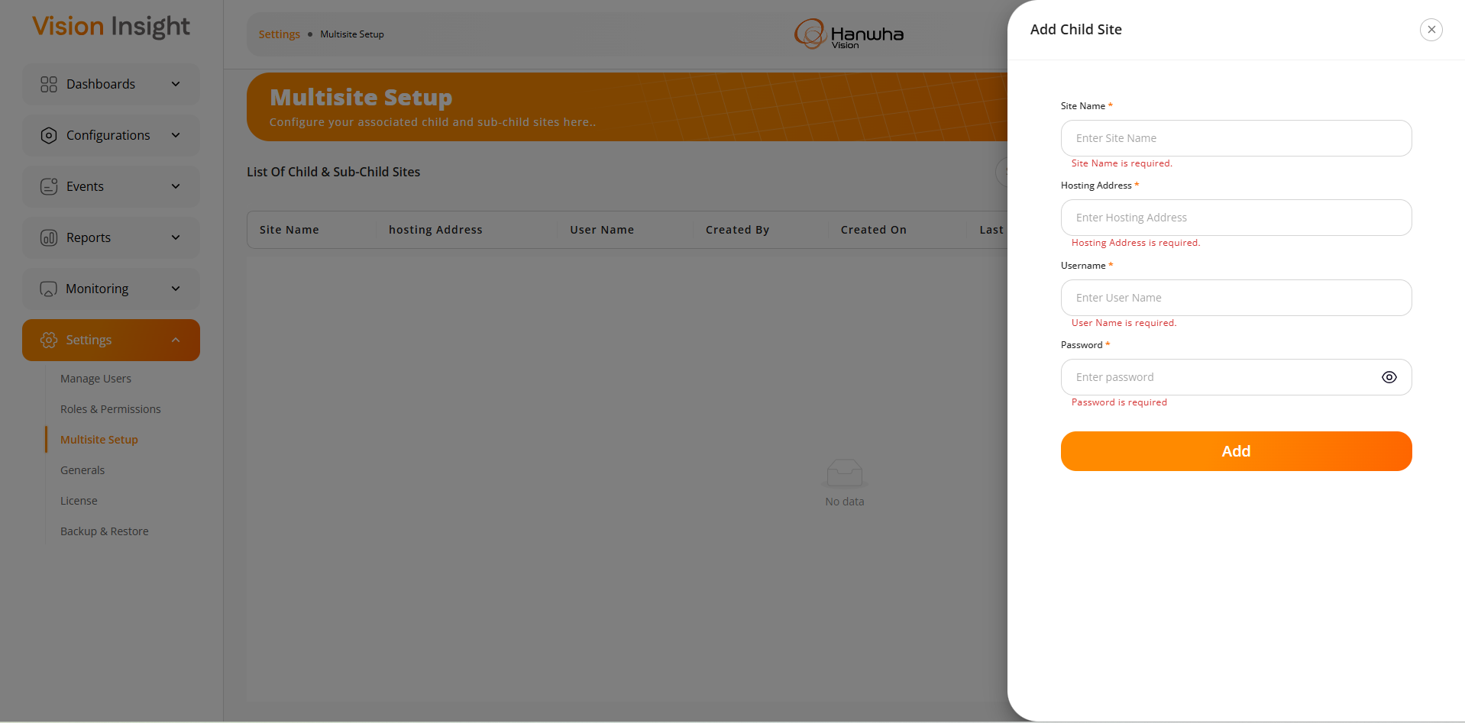
- The system will display an appropriate success or failure message after the child site is successfully created (or if the creation fails) in the system.
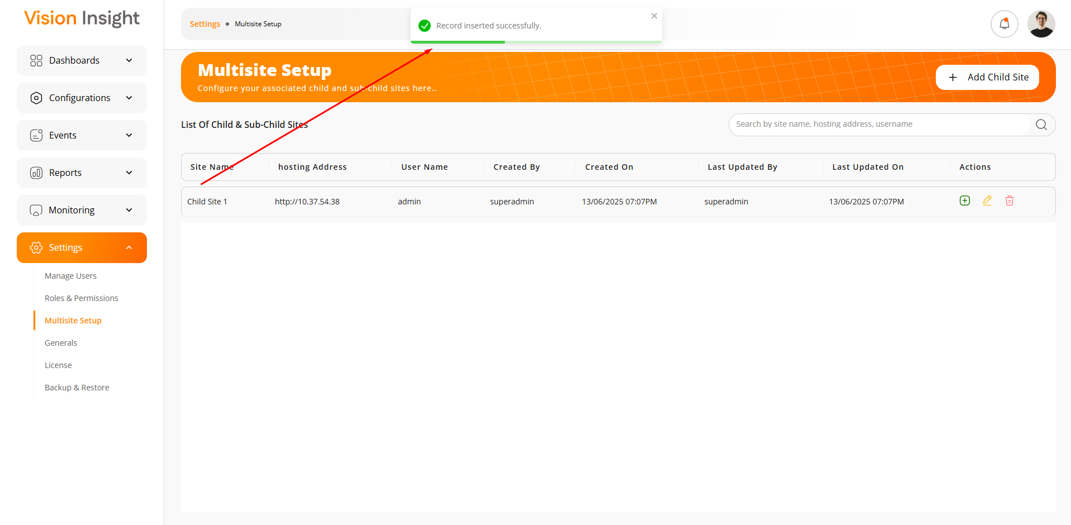

- The screen below illustrates the form used for editing existing child site information.
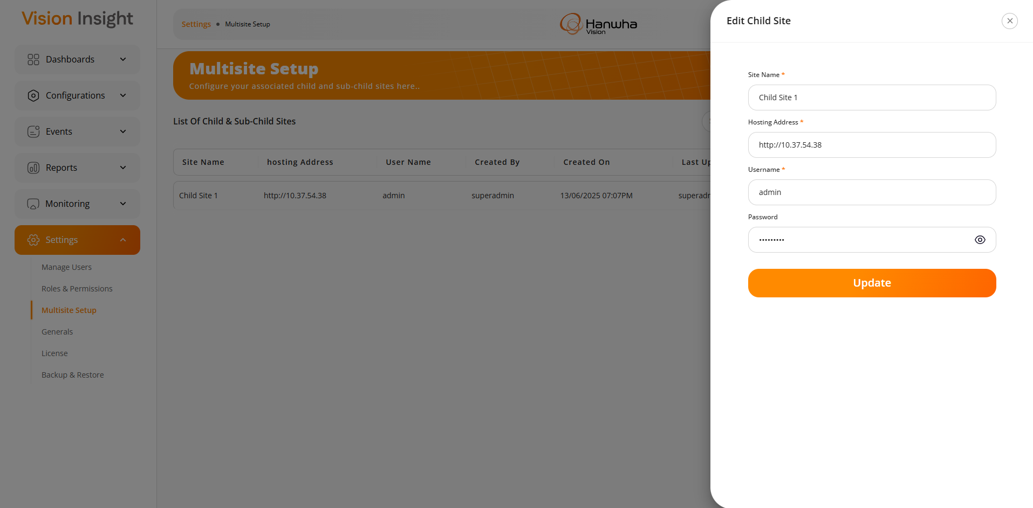
- The system will prompt a confirmation message when the user attempts to delete a specific child site from the list.
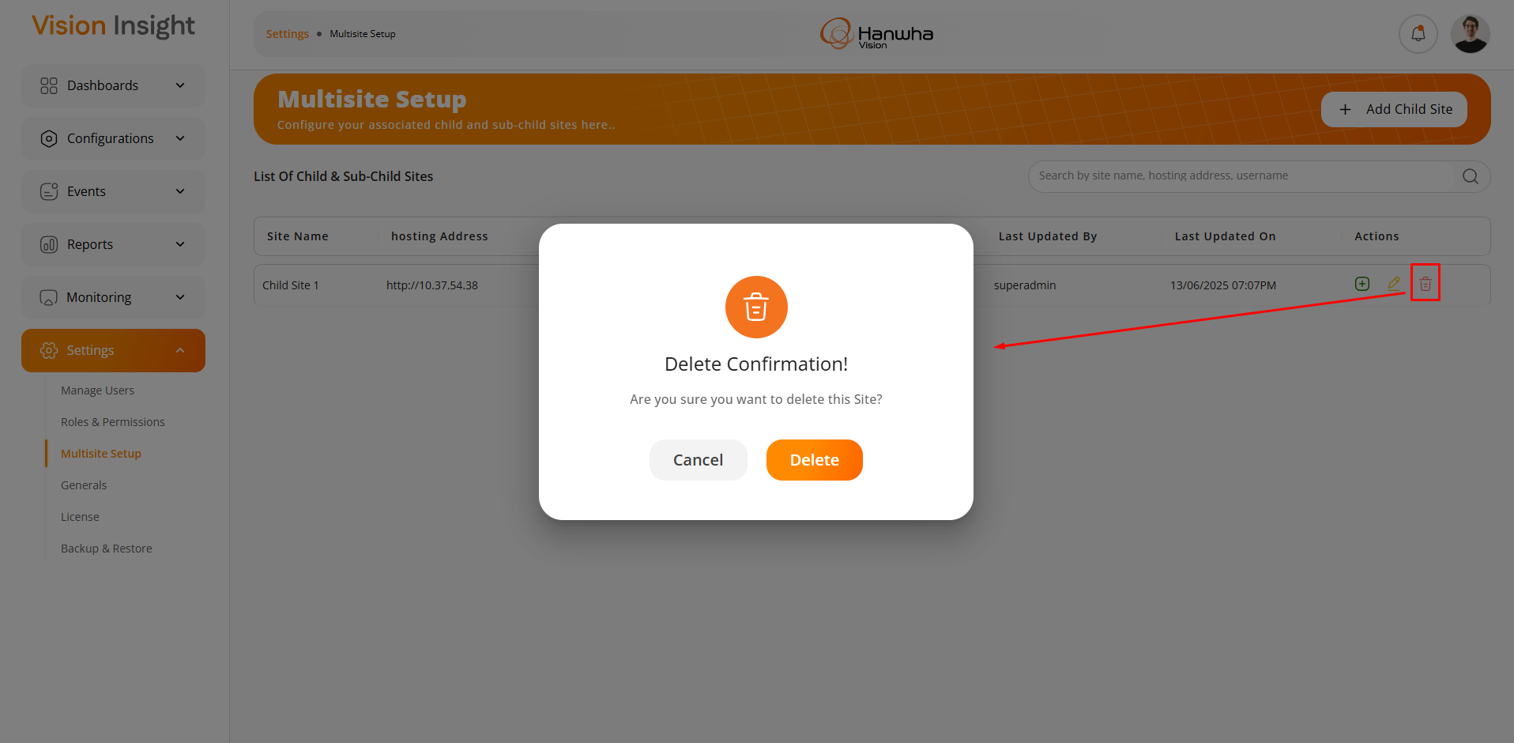

- The screen below represents the form for creating a sub-child site, allowing users to enter relevant details and submit the information for successful sub-child site creation.
- The system will perform all necessary validations when adding a new sub-child site to ensure that the entered information is valid and accurate.
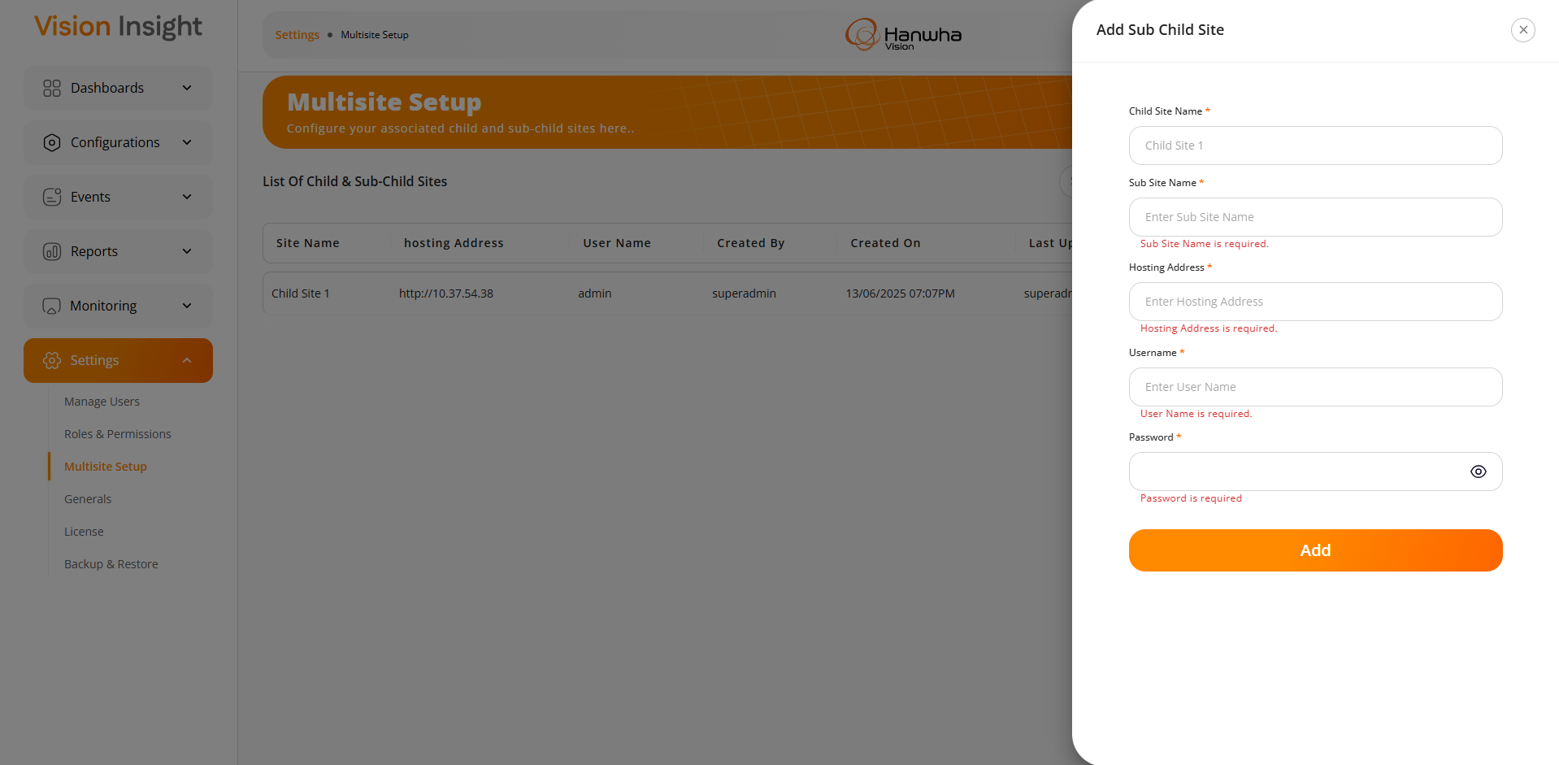
- The system will display an appropriate success or failure message after the sub-child site is successfully created (or if the creation fails) in the system.
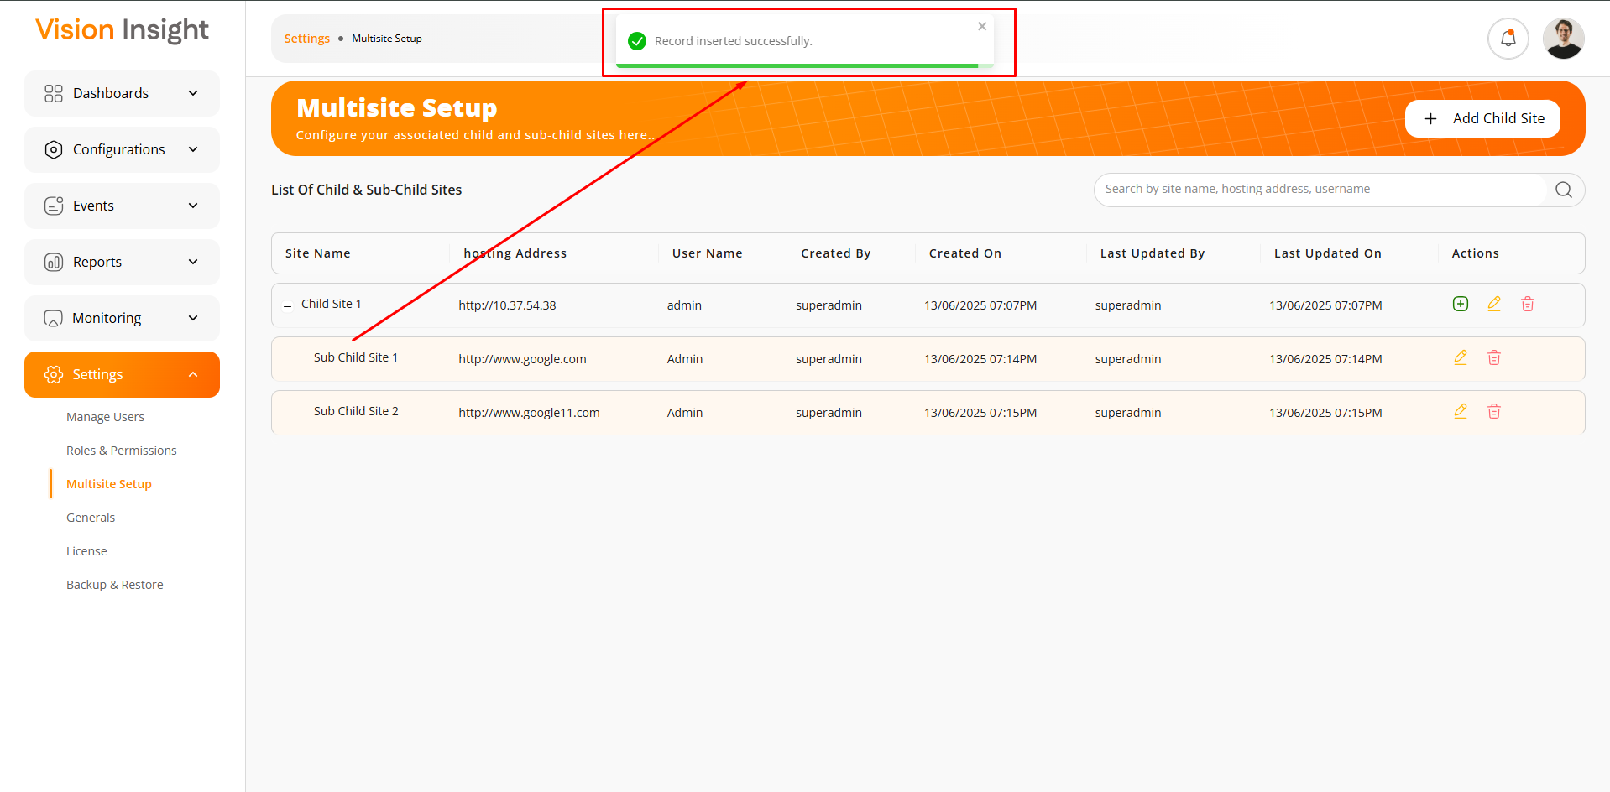

- The highlighted button below will appear when at least one sub-child site exists under a given child site. Users can expand the list of sub-child sites by clicking this button.
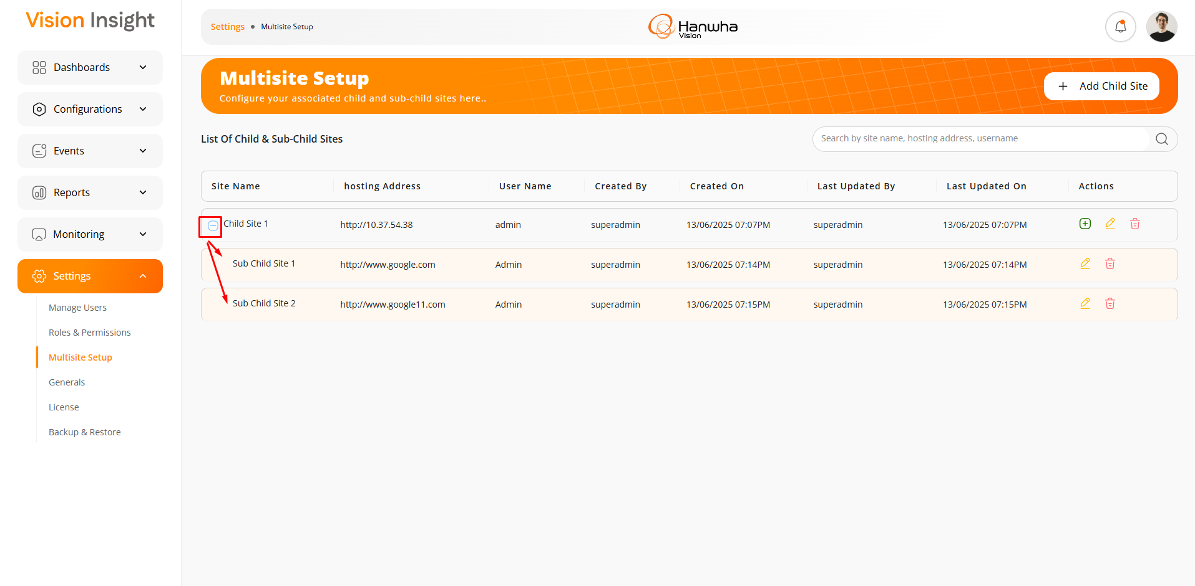
- Users will be able to edit or delete a sub-child site by clicking on the highlighted Edit or Delete buttons shown below.
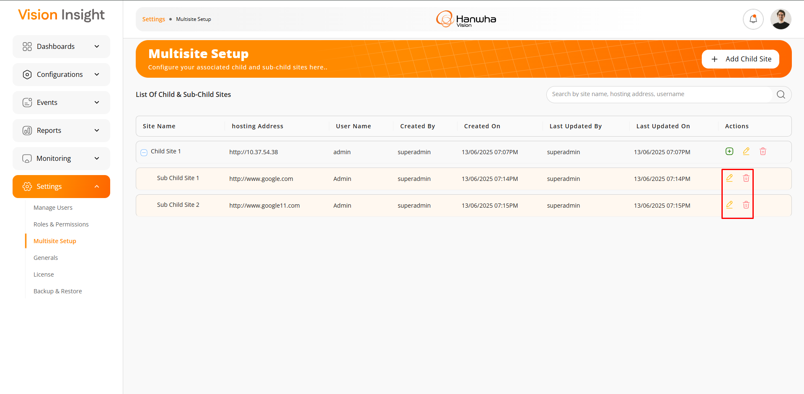

Data Ingestion (Partial)

The system includes a feature that automatically makes specific API calls in the background at predefined time intervals to ingest data into the database. The ingested data is then displayed on the BI Dashboard Web Application.

Since this is a fully automated background process with no user interaction, no permission management is required or handled by the system for this feature.

IMPORTANT NOTE:
Initially, it was planned to deliver this component partially under Milestone 3. However, due to changes in the execution plan and a more comprehensive flow of requirement gathering, SPEC INDIA successfully developed all the necessary cron jobs required for replicating data from the camera devices. These background processes will play a crucial role in supporting the development of associated features and functionalities within the upcoming BI Dashboard Web Application.

Screenshots:

- Data ingestion is managed through a set of defined cron jobs/schedulers that execute at specific intervals to ensure timely and automated data processing.
- We have implemented the following cron jobs in the system to replicate data from the camera devices, enabling consistent and reliable synchronization between the devices and the platform.

---- end of document ----

